Book 01 — Federal Agency Cloud Landing Zone
IPAM · SDN · DNS · PKI · Zero Trust — InfoBlox DDI Alignment to NIST, CISA, and FedRAMP
SSA Cloud Services Team
June 29, 2026

Draft Proposal — Subject to Review
This document is a draft proposal developed by the CSI Team (Cloud Services Infrastructure). It is an attempt at a comprehensive SSA-wide technical roadmap and has not been reviewed or approved by the SSA CIO Office, the Office of Information Security (OIS), or organizational leadership. All recommendations, vendor selections, control mappings, and implementation timelines are subject to revision pending formal review by the SSA CIO Office and organizational components.

Executive Summary
The Social Security Administration operates four distinct cloud environments — on-premises VMware Cloud Foundation, Microsoft Azure Government (GCC Moderate), AWS GovCloud, and Oracle Cloud Infrastructure (OCI) for OPM HRIT integration. Each environment uses a different Software Defined Networking fabric that replaces traditional broadcast DHCP with fabric-native IP assignment. Without a unified control layer, SSA has no cross-environment IP visibility, no unified DNS security policy, no automated certificate lifecycle, and must collect FedRAMP compliance evidence from four separate sources.
InfoBlox DDI — the market-leading platform for DNS, DHCP, and IP Address Management — solves all four problems from a single FedRAMP-authorized control plane (CSO FR2017257053, authorized January 2023, hosted on AWS GovCloud).
The three business outcomes this document demonstrates:
1. Operational Risk Elimination. A single Infoblox deployment replaces four separate DNS systems, four separate IP inventory processes, and four separate certificate-tracking tools. When a new cloud workload spins up in any environment, Infoblox automatically allocates an IP (cross-cloud conflict checked), creates DNS A and PTR records, and enrolls a machine certificate via SCEP — in seconds, without a change ticket. When a workload decommissions, all three are revoked atomically.
2. Continuous FedRAMP Compliance. Infoblox is one of a small number of DDI platforms with its own FedRAMP Moderate CSO authorization; verify current authorization on the FedRAMP Marketplace at time of procurement, meaning SSA inherits the DDI layer controls rather than re-proving them. Evidence for SC-20/21 (DNSSEC), CM-8 (inventory), IA-5(2) (certificates), AU-12 (audit), and IR-4 (incident response) is generated continuously and automatically — not assembled manually for annual assessments.
3. M365 GCC Boundary Enforcement. Microsoft publishes M365 GCC endpoint changes up to 12 times per year. Without automation, each change requires four manual updates across NSG rules, VPC security groups, RPZ policies, and VPN split-tunnel configurations — during which a gap exists between when Microsoft changes an endpoint and when SSA’s controls reflect it. Infoblox polls the Microsoft 365 IP & URL Web Service API daily and pushes all four enforcement updates simultaneously, closing the boundary gap window to minutes.
Vendor relationships: InfoBlox has formal technology partnerships with all three of SSA’s primary cloud vendors. InfoBlox BloxOne’s own FedRAMP-authorized service runs on AWS GovCloud, making AWS the infrastructure foundation. InfoBlox is a Microsoft Azure Technology Alliance Partner with native Microsoft Sentinel, Defender Threat Intelligence, and Entra ID integrations. InfoBlox is available on the Oracle Cloud Marketplace with OCI connector support for the OPM HRIT integration path.
InfoBlox DDI can be deployed via two architecturally distinct paths; the choice determines the FedRAMP authorization inheritance model:
Path A — BloxOne DDI (Cloud-Managed, FedRAMP ATO Inherited)
InfoBlox operates the management control plane on AWS GovCloud (CSO FR2017257053, authorized January 2023). The agency deploys BloxOne On-Prem Hosts in each environment; they connect to the InfoBlox-hosted management plane. FedRAMP authorization is inherited from InfoBlox’s ATO — the agency does not carry this component independently. Procurement via AWS GovCloud Marketplace (no separate IDIQ required). Best fit if the agency prefers a managed control plane and the simplest FedRAMP inheritance path.
Path B — NIOS Grid (Agency-Operated, On-Premises Hub)
The agency deploys an InfoBlox NIOS virtual appliance as the Grid Master on-premises (VMware ESXi or physical InfoBlox appliance). Grid Members are deployed in each environment (AWS GovCloud, Azure Government, Oracle OCI, additional on-premises sites) as spokes. The on-premises Grid Master is the authoritative hub; all Grid Members replicate configuration from it and handle local DNS/DHCP/IPAM for their environment. The agency documents NIOS within its own FedRAMP boundary — no ATO inheritance from InfoBlox’s CSO. Procurement via GSA Schedule (GS-35F) or agency IDIQ contract vehicle.
SSA topology note: For SSA’s multi-cloud architecture spanning AWS GovCloud, Azure Government, Oracle OCI, and on-premises VMware, Path B — NIOS Grid with an on-premises Grid Master — more closely matches SSA’s topology. No single cloud provider is the hub; all four environments are equal spokes of the on-premises control plane. The decision between Path A and Path B should involve OIS and the CIO Office, as it determines whether InfoBlox is a shared-responsibility SaaS or an agency-operated infrastructure component. Agency selection pending.

What Is a Federal Cloud Landing Zone?
A Cloud Landing Zone is the foundational, pre-configured environment that a federal agency provisions before any workload is deployed. It establishes the guardrails — network topology, identity controls, logging pipelines, encryption policies, and security baselines — that every subsequent workload inherits automatically.
For SSA operating under FedRAMP Moderate, the landing zone must satisfy four overlapping frameworks simultaneously:
- NIST SP 800-53 Rev 5 — the control catalog from which FedRAMP Moderate baselines are drawn
- CISA Zero Trust Maturity Model v2.0 — five pillars with three cross-cutting capabilities
- FedRAMP Moderate — boundary definition, continuous monitoring, evidence packaging
- FedRAMP 20x Consolidated Rules (2026) — automated, machine-readable compliance evidence enforced by infrastructure-as-code; Class A/B/C certification pipelines; mandatory January 1, 2027
FedRAMP 20x Consolidated Rules — June 25, 2026: FedRAMP published its Consolidated Rules for 2026 on June 25, 2026, transitioning 20x from pilot status to a fully available certification path with three classification tiers: Class A (opens August 3, 2026), Class B and C (open August 31, 2026). FedRAMP Ready submissions cease July 28, 2026. The Consolidated Rules become mandatory for all certified systems on January 1, 2027. Machine-readable structured rules are available in JSON format via GitHub for AI agent integration. InfoBlox DDI’s WAPI REST interface delivers machine-readable KSI evidence — the exact format the 20x framework requires — without manual assembly.
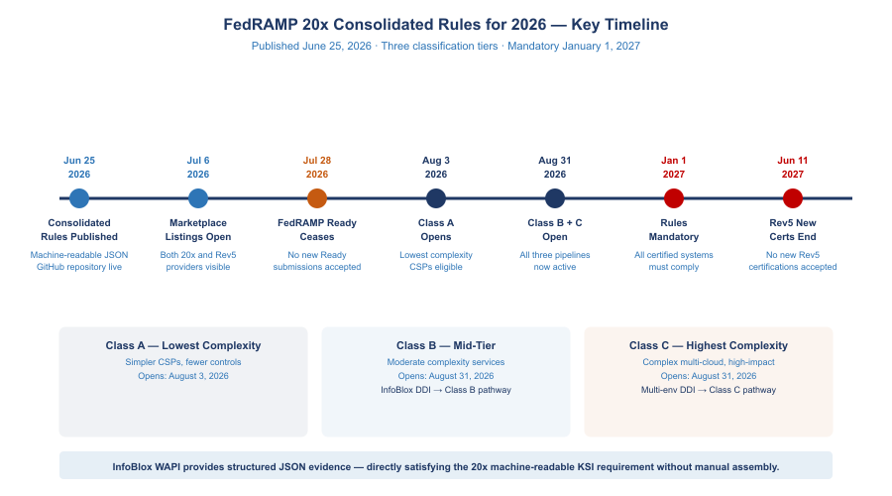
FedRAMP 20x Consolidated Rules for 2026 — Class Timelines and Key Dates
The Core Insight: DNS, DHCP, and IP address management (DDI) are not optional infrastructure services — they are foundational security controls. Every device that joins a network, every cloud workload that provisions, every certificate that authenticates a service depends on DNS and IP assignment working correctly. A landing zone without unified DDI has a structural security gap at its foundation.

SSA’s Multi-Cloud Landing Zone Scope
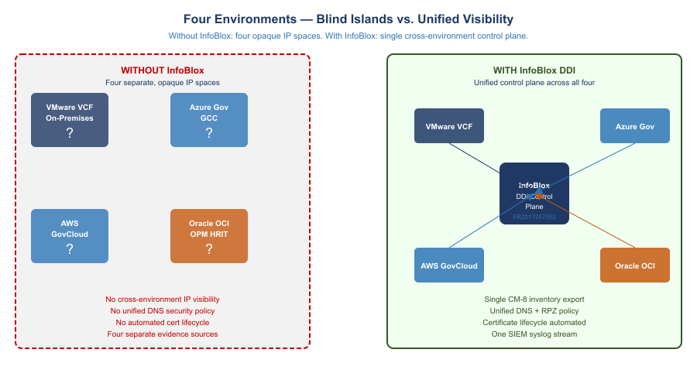
Four Environments — Blind Islands vs. Unified InfoBlox Visibility
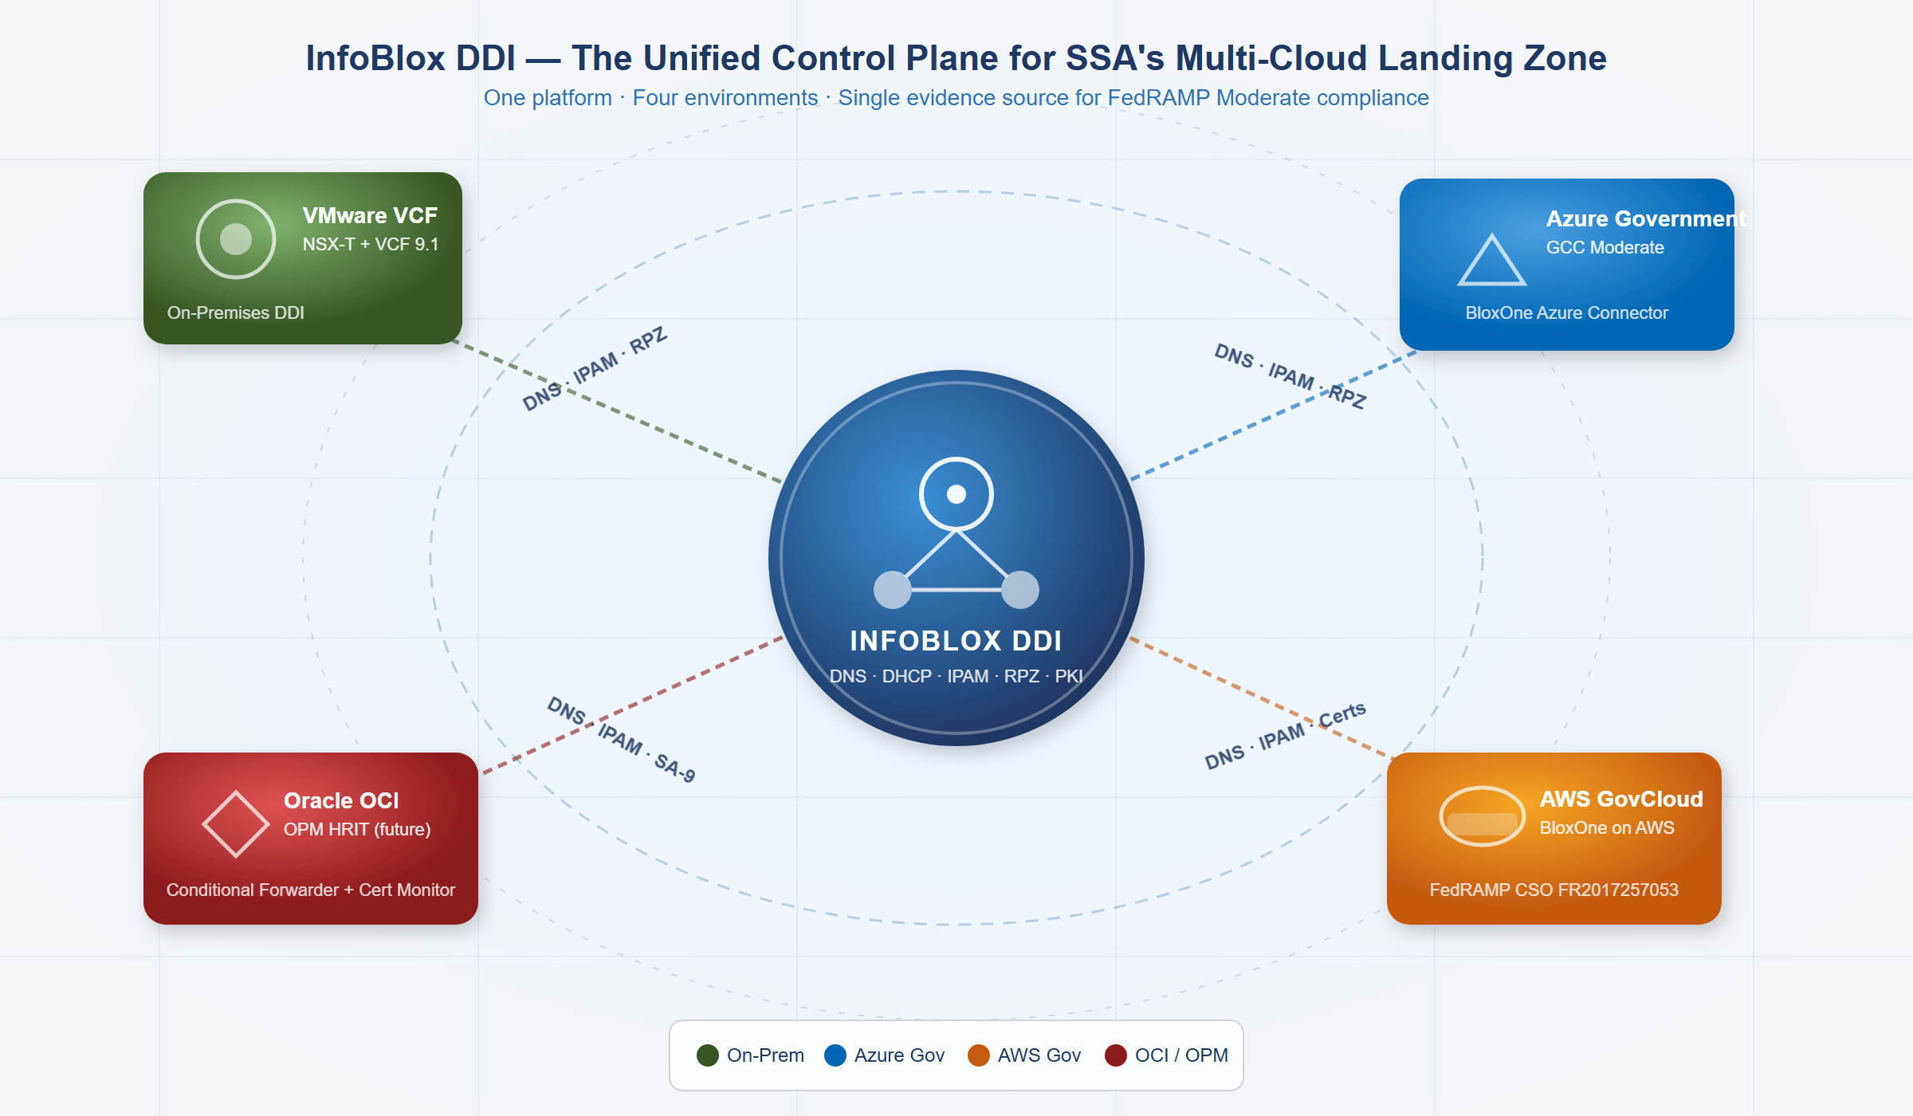
InfoBlox DDI as the Unified Control Plane for SSA’s Four-Environment Landing Zone
SSA’s landing zone spans four discrete cloud environments that must behave as a single logical security domain:
SSA Multi-Cloud Environments {.striped .hover}
Environment | Platform | SDN Technology | DHCP/IP Model | FedRAMP Boundary
On-Premises DC | VMware VCF / ESXi | NSX-T overlay (VXLAN/Geneve) | NSX-T DHCP Server Profiles on T1/T0 Gateways | Agency ATO
Azure Government GCC | Microsoft Azure | Azure VNet (SDN fabric, no broadcast) | Azure fabric assigns IPs; DHCP is abstracted away | Azure Government FedRAMP High
AWS GovCloud | Amazon AWS | VPC with ENI/Nitro hypervisor | VPC DHCP Options Sets; EC2 metadata service | AWS GovCloud FedRAMP High
Oracle Cloud OCI (OPM HRIT) | Oracle OCI | VCN with VNIC overlay | OCI DHCP options; instance metadata at 169.254.169.254 | OPM ATO (external)
The critical observation: none of these four environments uses traditional broadcast DHCP. Each uses a form of SDN where IP address assignment is managed by the hypervisor fabric — not a classic DHCP server. Without a unified IPAM overlay, these four IP spaces are opaque to each other and to SSA’s security operations center.

SDN and the End of Traditional DHCP
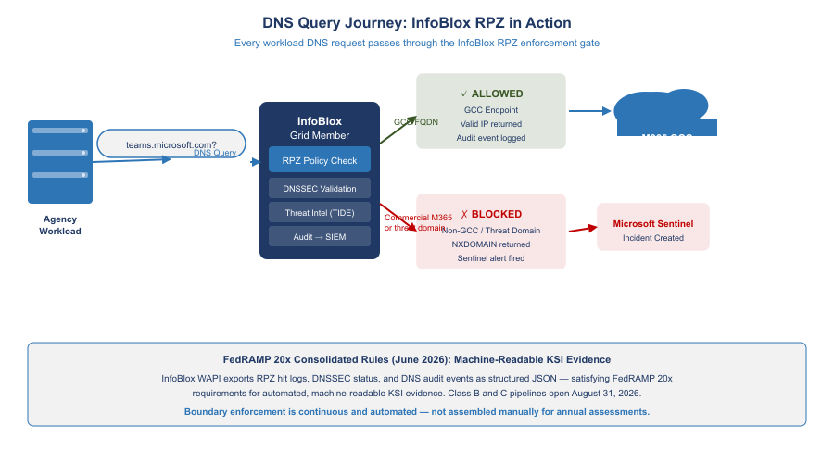
DNS Query Journey: InfoBlox RPZ Enforcement Gate
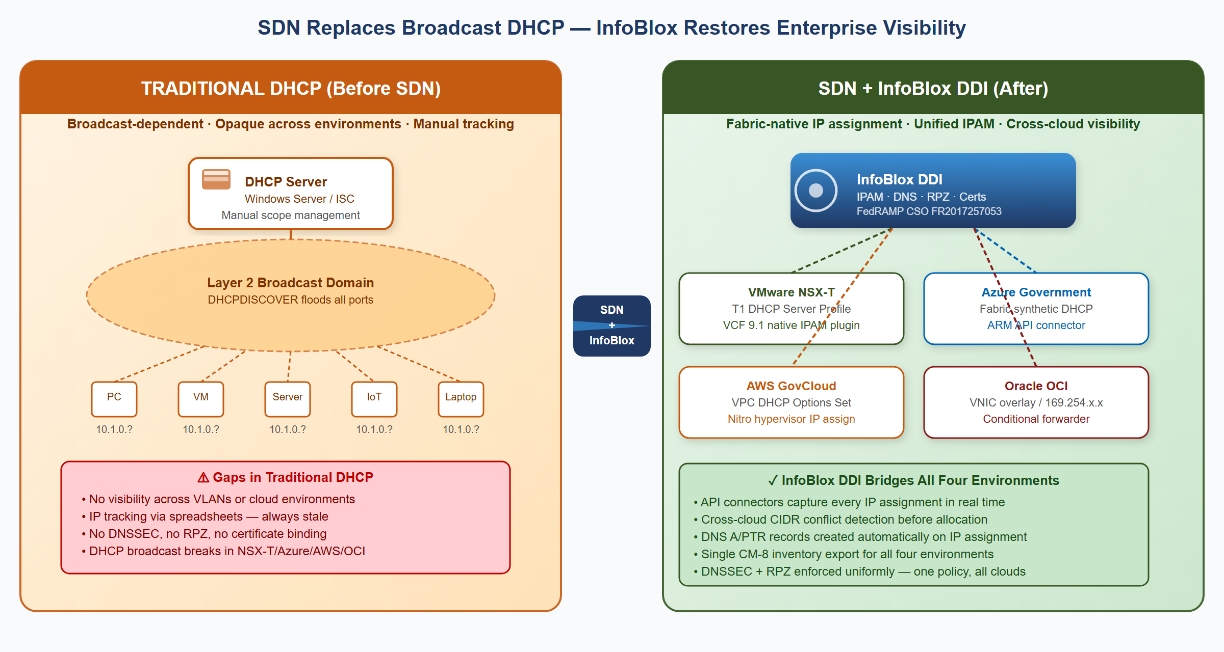
SDN Replaces Broadcast DHCP — InfoBlox Restores Enterprise Visibility
Traditional DHCP (RFC 2131) depends on Layer 2 broadcast. This model fundamentally breaks in Software Defined Networking environments because SDN uses overlay protocols (VXLAN, Geneve, STT) that operate at Layer 3 and suppress Layer 2 broadcasts by design.

VMware NSX-T: DHCP Server Profiles and VCF 9.1 Native Integration
VMware NSX-T replaces broadcast DHCP with DHCP Server Profiles attached to T1 Gateways. The NSX-T control plane intercepts DHCP requests at the logical switch level — the request never hits the physical network. Traditional DHCP servers are completely bypassed.
VMware Cloud Foundation 9.1 (released May 2026) introduced native InfoBlox DDI integration as a first-class feature:
- VCF Automation tenant requests a new network segment
- VCF background service calls InfoBlox NIOS WAPI or BloxOne REST API to reserve an IP block
- NSX-T creates the logical segment using the InfoBlox-allocated CIDR
- InfoBlox records the segment name, CIDR, VLAN/VNI, and tenant as extensible attributes
- When VMs deploy, NSX-T DHCP assigns IPs; InfoBlox receives assignments via the IPAM plugin
- DNS A/PTR records for each VM are created automatically — no manual DNS entry required
VCF 9.1 Significance: Before VCF 9.1, NSX-T InfoBlox integration required custom scripts and manual configuration. VCF 9.1 makes InfoBlox the native, default IPAM backend for VMware Cloud Foundation — meaning every new VCF deployment at SSA can have InfoBlox IPAM built in from day one.

Microsoft Azure Government: The Fabric Replaces DHCP
Azure Virtual Networks do not use DHCP in the traditional sense. When a VM is deployed, the Azure hypervisor fabric directly assigns the IP — the VM receives the IP via a synthetic DHCP response injected by the Azure host agent. There is no DHCP broadcast.
Azure reserves five IP addresses in every subnet that cannot be assigned (x.x.x.0 network, x.x.x.1 gateway, x.x.x.2–3 Azure DNS, x.x.x.255 broadcast). Beyond these, IP assignment is managed entirely by the Azure control plane.
InfoBlox’s Azure connector continuously pulls VNet subnet configurations and VM NIC IP assignments via the Azure Resource Manager API, writing every Azure IP into the Azure-GCC Network View in the InfoBlox IPAM database.

AWS GovCloud: VPC DHCP Options and the Nitro Hypervisor
AWS VPCs use DHCP Options Sets to specify DNS servers and domain names, but the actual IP assignment is managed by the AWS Nitro hypervisor — not a traditional DHCP server. EC2 instances receive IPs via a synthetic DHCP interaction at the VPC CIDR +2 address.
Replacing the default AmazonProvidedDNS with the InfoBlox Grid Member IP in the VPC DHCP Options Set directs all EC2 DNS queries through the enterprise RPZ and DNSSEC validation layer. InfoBlox’s AWS connector syncs EC2 instance IP assignments, subnet CIDRs, and VPC IPAM pool allocations into the AWS-GovCloud Network View.

Oracle OCI: VCN DHCP Options and the VNIC Overlay
OCI uses Virtual Network Interface Cards (VNICs) inside Virtual Cloud Networks. OCI’s internal DHCP implementation is fabric-native — the OCI hypervisor responds to DHCP requests on behalf of each subnet from the metadata service at 169.254.169.254.
For OPM HRIT, SSA cannot control OCI DHCP Options because OPM manages the tenancy. However, SSA can document all known OPM HRIT service IPs as external host records in InfoBlox (read-only OCI Network View) and configure conditional forwarders for OPM HRIT FQDNs routing through the FastConnect path.

InfoBlox as the SDN-Aware IPAM Control Plane
InfoBlox DDI operates as a control plane over SDN environments — not replacing the SDN fabric’s internal IP assignment mechanisms, but serving as the authoritative record and policy engine above them.
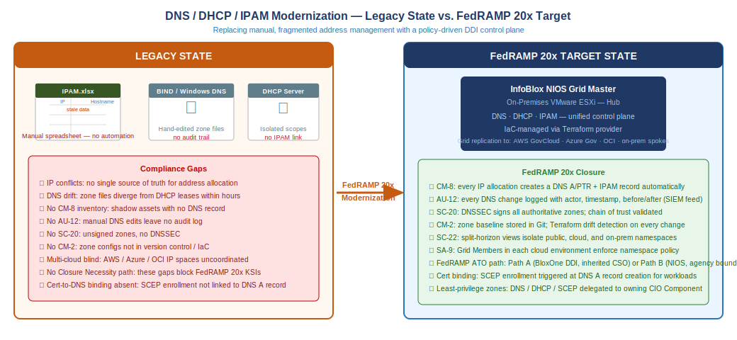
From Manual Address Management to a Policy-Driven DDI Control Plane

What InfoBlox Provides That SDN Cannot
InfoBlox Value-Add Over Native SDN {.striped .hover}
Capability | What SDN Platforms Provide | What InfoBlox Adds
IP assignment | Per-environment only | Cross-cloud conflict detection before allocation
DNS | Per-environment resolver | Authoritative + recursive with DNSSEC, unified across all four
DHCP inventory | Per-VPC/VNet/segment dashboard | Single CM-8-ready inventory spanning all environments
Certificate management | None / per-CA | Certificate Tracker links cert to IP host record, expiry alerts
Threat blocking | Per-environment (DNS Firewall, NSG) | Single RPZ policy propagated to all Grid Members in seconds
Audit logging | Per-environment log silo | Single syslog stream to SIEM, AU-12 evidence
IaC integration | Per-cloud provider only | Terraform InfoBlox provider works across all environments

Grid Master Deployment — On-Premises VMware and the Trust Case
For SSA, the InfoBlox NIOS Grid Master should be deployed as a virtual machine on on-premises VMware infrastructure (Path B from the Executive Summary). This is not only a technical topology choice — it is a trust architecture decision. DNS, DHCP, and IPAM together constitute the network naming and addressing control plane: every device’s address, every workload’s hostname, and every certificate’s subject name flows through them. Placing the Grid Master on-premises means SSA retains:
- Hypervisor-layer control — the Grid Master VM runs under SSA infrastructure team governance, not a cloud provider’s control plane
- Physical network isolation — the master is reachable from all four environments via dedicated management interfaces, not via public internet or cloud-provider backbone
- No single-cloud dependency — if any one cloud environment (AWS GovCloud, Azure Government, OCI) experiences an outage or a control-plane incident, the Grid Master continues to function from on-premises
- Boundary clarity — the NIOS Grid falls within SSA’s own FedRAMP authorization boundary; the agency controls the ATO evidence rather than inheriting it from a vendor CSO
Trust rationale: DNS poisoning, DHCP scope hijacking, and IPAM record manipulation are among the highest-impact attack vectors against network infrastructure. An adversary who controls the Grid Master can redirect any FQDN, drain any IP subnet, or suppress any workload’s DNS record — effectively owning the naming plane for all four SSA environments simultaneously. On-premises VMware deployment keeps this function under SSA’s direct institutional control.
OIS and the CIO Office must validate the trust boundary decision and define the Grid Admin role-holder accountability model before the Grid is deployed.
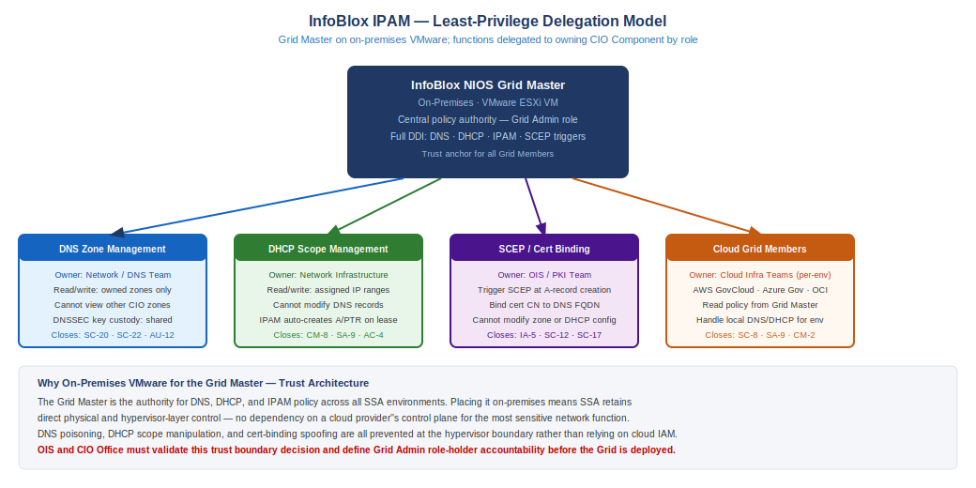
InfoBlox NIOS Grid Master — Least-Privilege Delegation Model

Least-Privilege Role Delegation
The Grid Master holds total administrative authority over DNS, DHCP, and IPAM. That authority must not reside in a single operational role. SSA should structure InfoBlox administrative access as four delegated function areas, each assigned to the owning CIO Component with read/write access scoped only to their area:
InfoBlox Least-Privilege Role Delegation {.striped .hover}
Function | Delegated To | Scope | Cannot Access
DNS zone management | Network / DNS Team | Read/write on assigned DNS zones; DNSSEC key custody shared with OIS | Other CIO Component zones; DHCP config; SCEP triggers
DHCP scope management | Network Infrastructure Team | Read/write on assigned IP subnets and DHCP scopes | DNS zone records; other teams’ subnets; SCEP policy
SCEP / cert binding | OIS / PKI Team | Trigger SCEP enrollment at A-record creation; bind cert CN to DNS FQDN | Zone configuration; DHCP scopes; other teams’ cert policies
Cloud Grid Member management | Per-environment Cloud Infra Teams (AWS GovCloud, Azure Government, OCI) | Configure local Grid Member for assigned cloud environment | Grid Master policy; other environments’ Grid Members
Grid Admin (full authority) | CIO/OIS-designated Grid Administrator | Full DDI policy control | — (must be protected with MFA + privileged access workstation)
DNS function separation applies to sub-functions as well. Within DNS zone management, component-level zone delegation allows different CIO Components to own their sub-namespaces:
- aws.ssa.gov sub-zone — delegated to Cloud Infrastructure team (AWS)
- azure.ssa.gov sub-zone — delegated to Cloud Infrastructure team (Azure)
- oci.ssa.gov sub-zone — delegated to Cloud Infrastructure team (OCI)
- onprem.ssa.gov sub-zone — delegated to on-premises Network Infrastructure team
- apps.ssa.gov sub-zone — delegated to Application Development / DevOps
Each delegated zone owner can create, modify, and delete records within their zone without touching any other component’s DNS namespace. The Grid Master enforces zone-level access control; cross-zone queries still resolve via Grid Member forwarding, but record modification rights are strictly scoped.

Microsoft Partnership: M365 GCC Endpoint Lifecycle
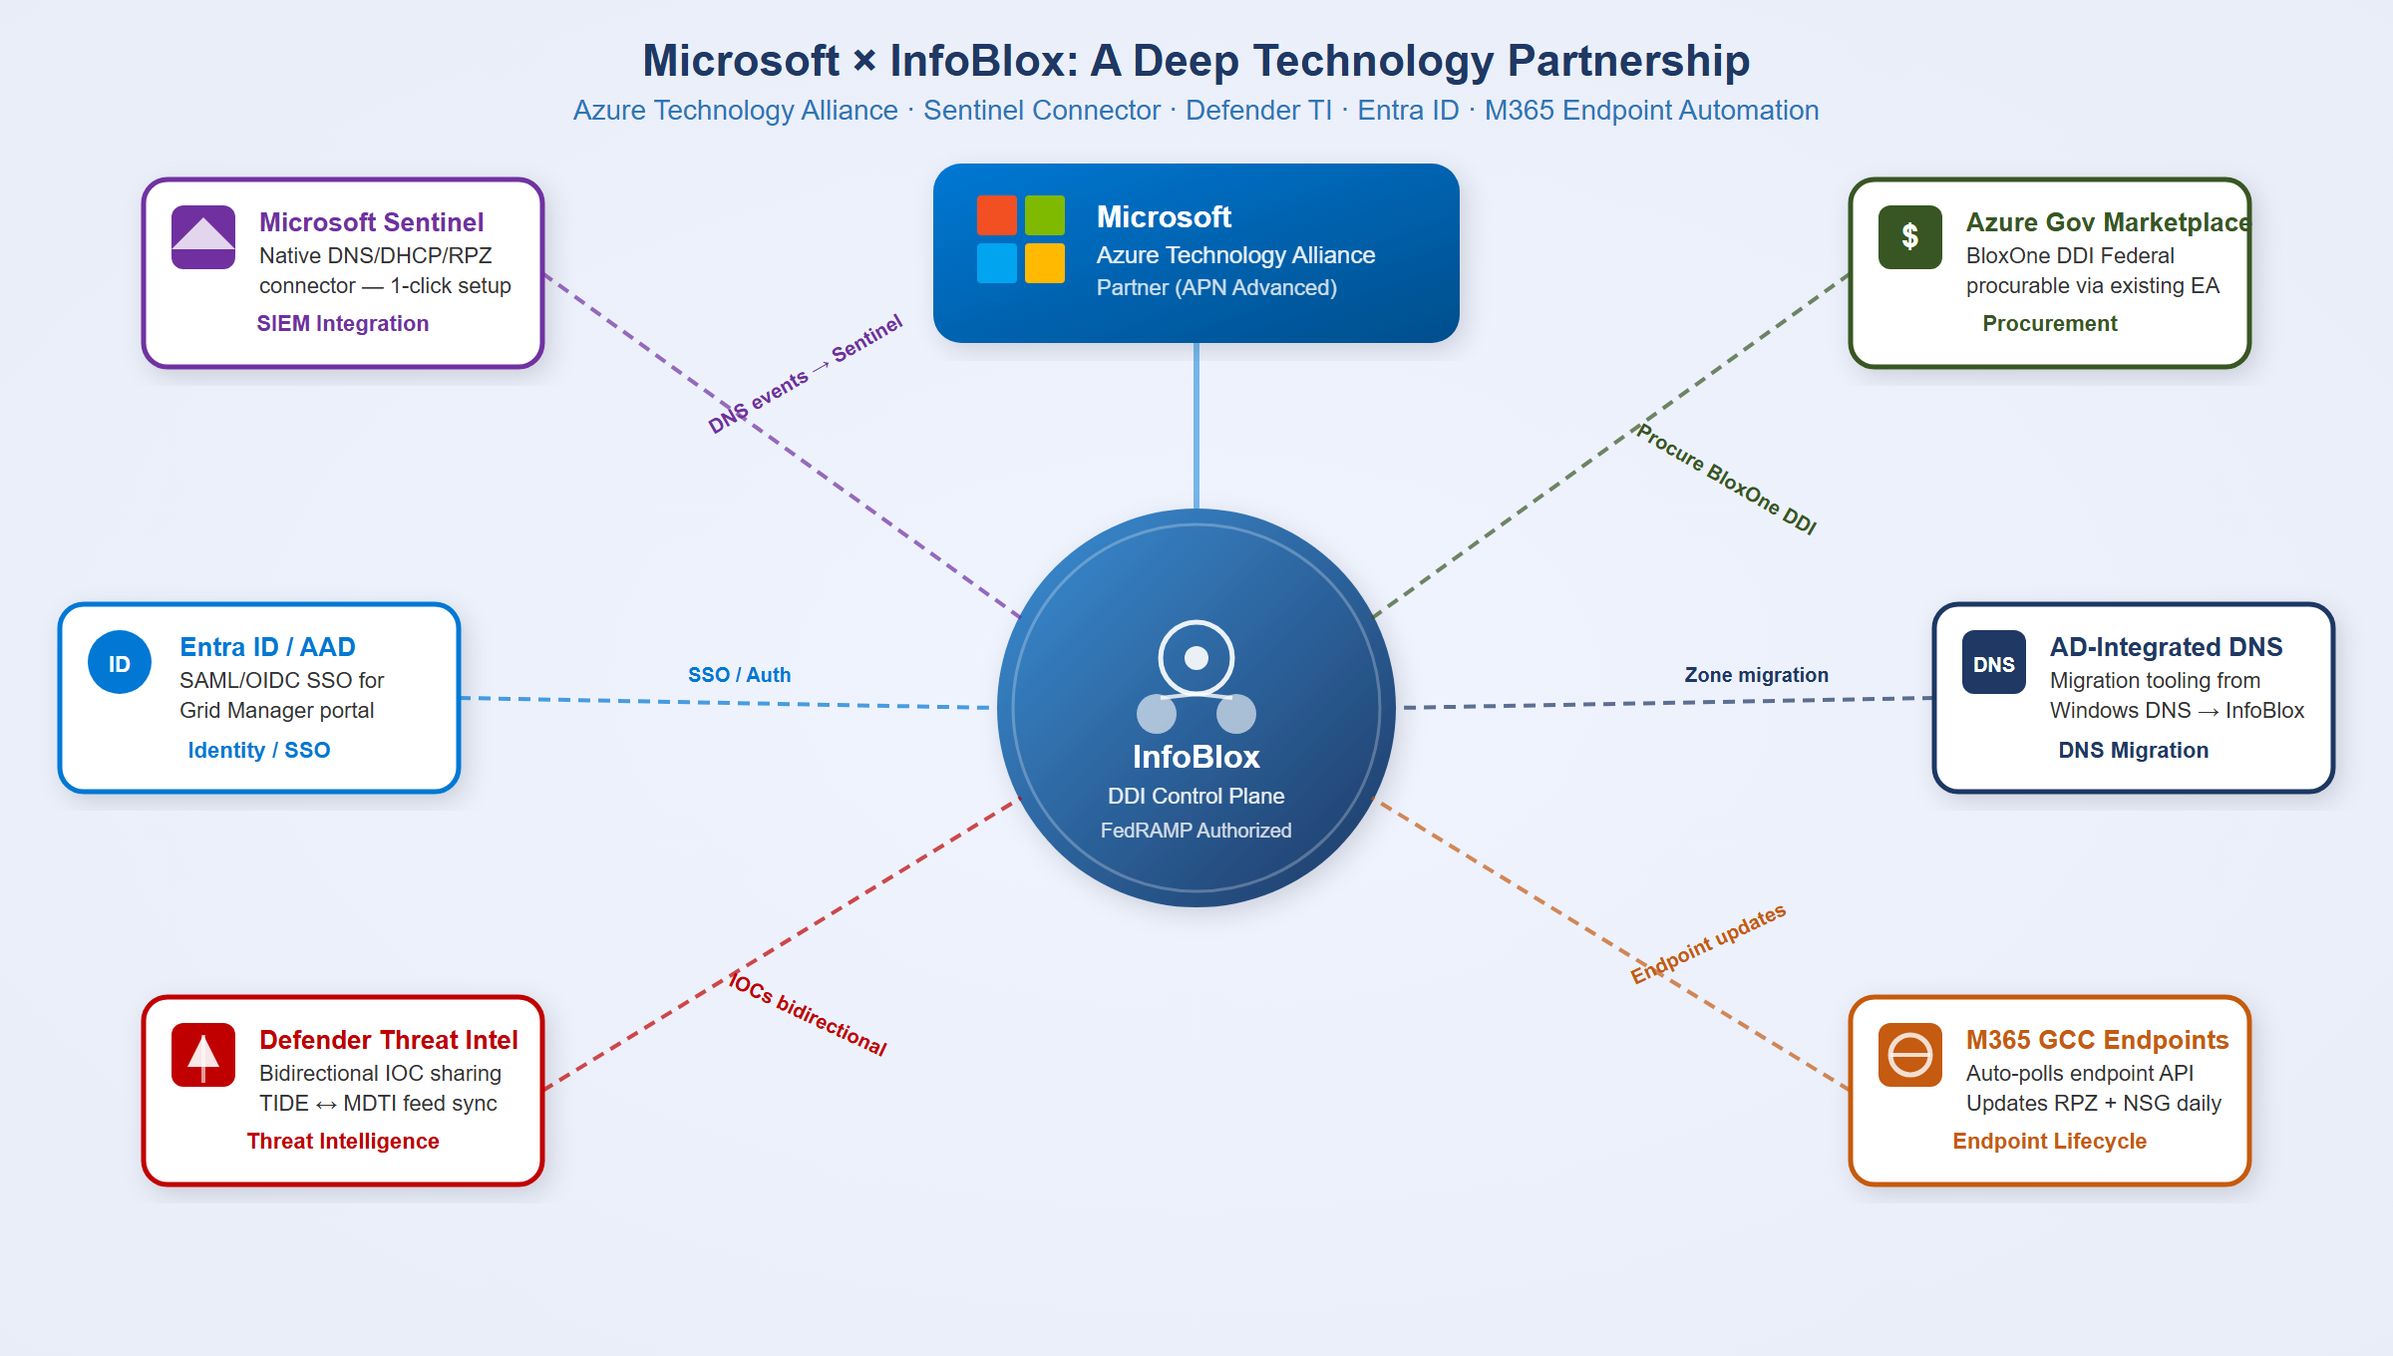
Microsoft × InfoBlox Technology Partnership — Six Integration Points
InfoBlox and Microsoft have a formal Azure Technology Alliance Partnership with six distinct integration points:
Microsoft-InfoBlox Integration Points {.striped .hover}
Integration | What It Does
Microsoft Sentinel Native Connector | First-party Sentinel content pack — DNS Security Events, DHCP events, RPZ blocks stream to Sentinel without custom parsing
Defender Threat Intelligence (MDTI) | Bidirectional IOC sharing between InfoBlox TIDE and MDTI — a domain blocked by MDTI is also blocked by InfoBlox RPZ
Entra ID / Azure AD SSO | InfoBlox Grid Manager and BloxOne portal support Entra ID SAML/OIDC — Grid admin auth governed by SSA Conditional Access policies
Azure Government Marketplace | BloxOne DDI Federal is procurable via existing Azure EA/ELA agreements — no separate IDIQ
AD-Integrated DNS Migration | Documented migration tooling from Windows DNS zones to InfoBlox Grid — AD still replicates, InfoBlox serves authoritative records
M365 GCC Endpoint Lifecycle | InfoBlox polls Microsoft 365 IP & URL Web Service API and auto-updates all enforcement layers

M365 GCC Boundary Enforcement
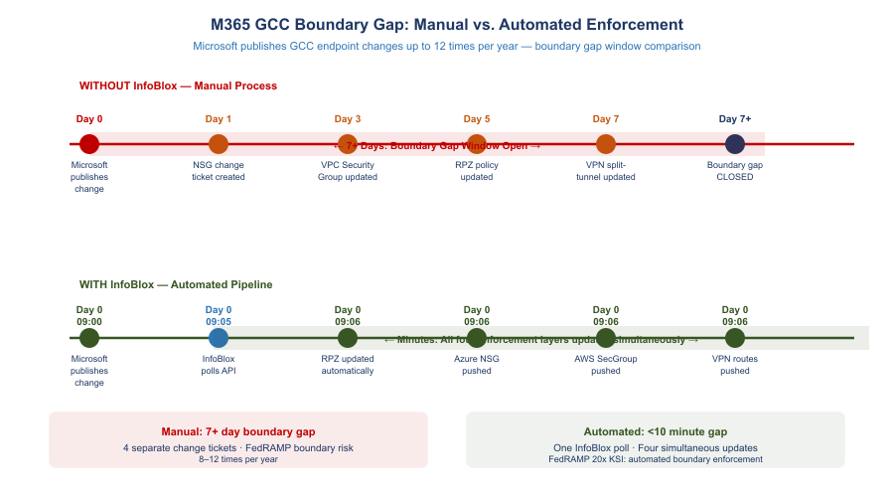
M365 GCC Boundary Gap: Manual vs. Automated Enforcement
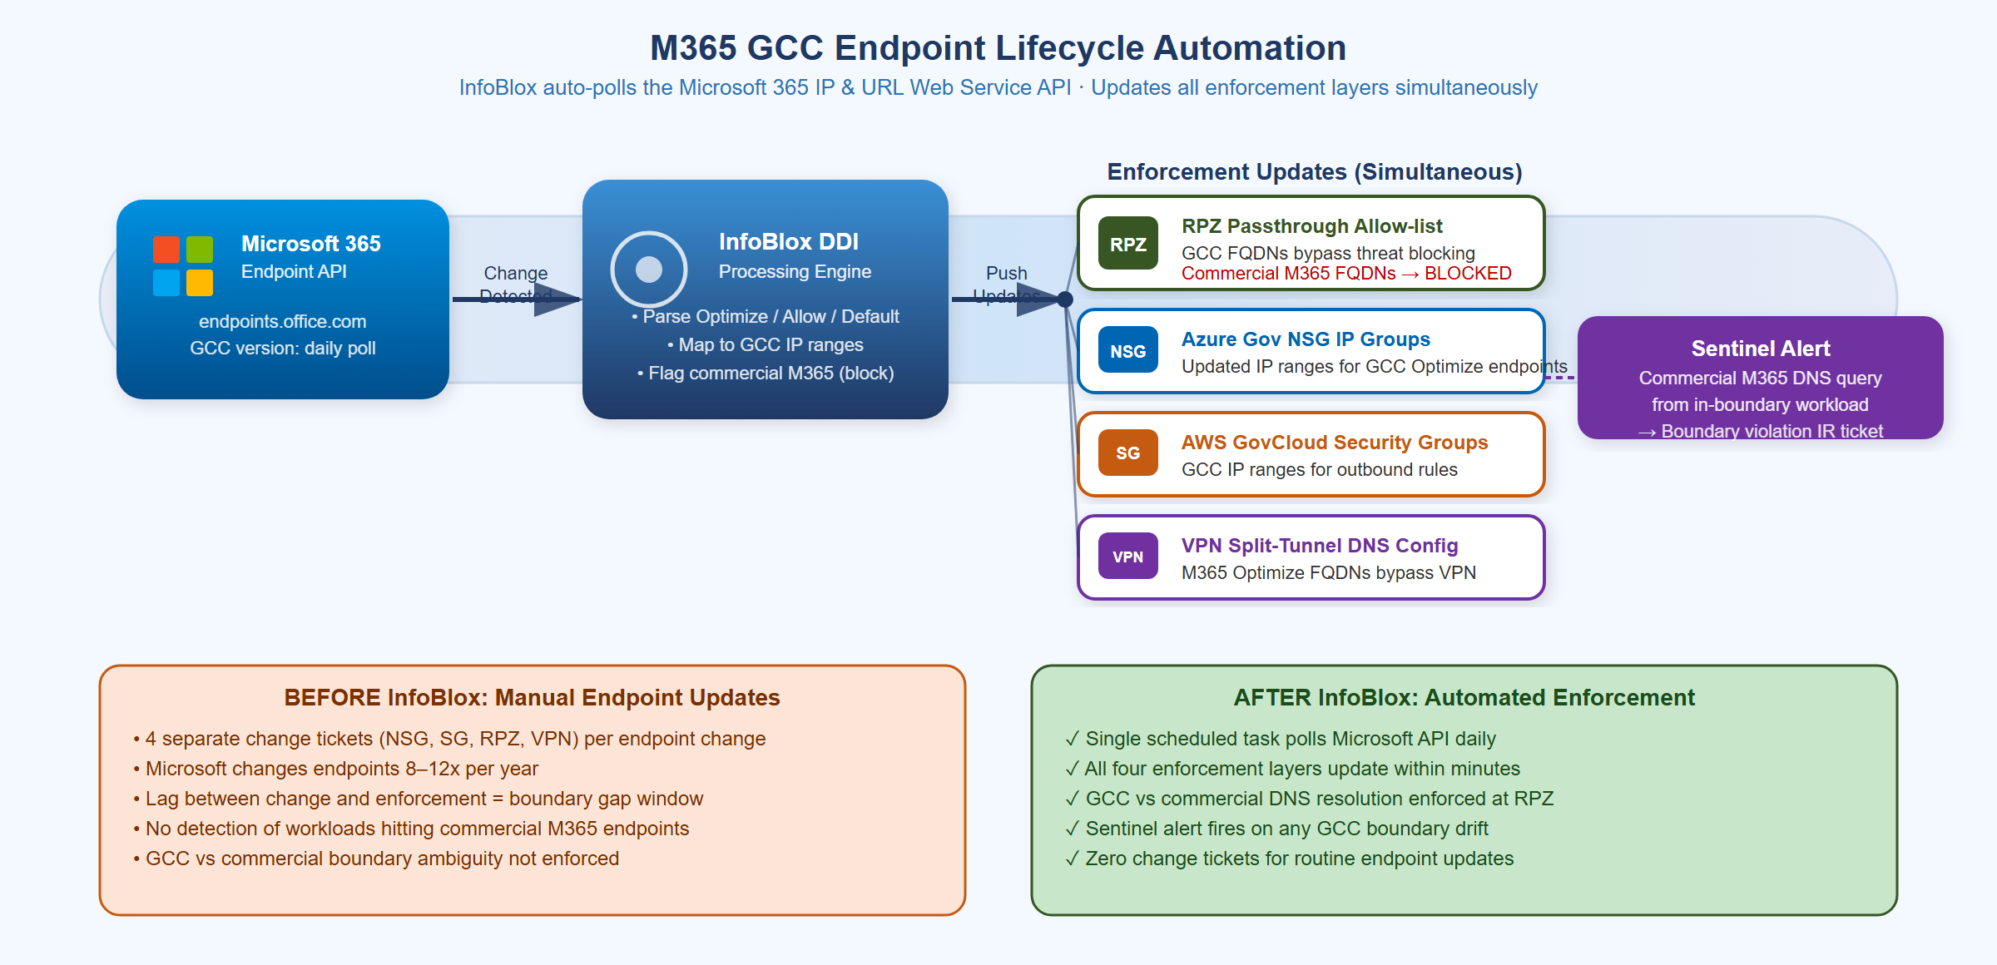
M365 GCC Endpoint Lifecycle Automation — One Poll, Four Enforcement Updates
Microsoft publishes M365 endpoint changes (IP ranges + FQDNs) via the Office 365 IP and URL Web Service API. For GCC Moderate specifically, Microsoft publishes a separate GCC endpoint list — the commercial and GCC IP ranges are different and must not be mixed. A workstation accidentally reaching a commercial Microsoft 365 endpoint instead of the GCC endpoint is a FedRAMP boundary violation.
InfoBlox provides the automated enforcement pipeline:
- Daily poll of the Microsoft M365 GCC endpoint API (version-change detection)
- RPZ passthrough allow-list — GCC FQDNs explicitly allowed through threat blocking
- RPZ block list — commercial M365 FQDNs (non-GCC) blocked at DNS layer
- Azure NSG IP Group update — GCC Optimize IP ranges pushed to Azure Government
- AWS GovCloud Security Group update — GCC IP ranges for outbound rules
- VPN split-tunnel DNS — M365 Optimize FQDNs route via local interface, not VPN tunnel
- Sentinel alert — any DNS query from an in-boundary workload to a commercial M365 endpoint triggers an IR ticket
Without InfoBlox automation: Each of Microsoft’s 8–12 annual endpoint changes requires four separate change tickets across NSG, Security Groups, RPZ, and VPN config — during which SSA has a boundary gap window. With InfoBlox, all four update within minutes of Microsoft’s API publishing the change.

AWS Partnership: BloxOne Runs ON AWS GovCloud
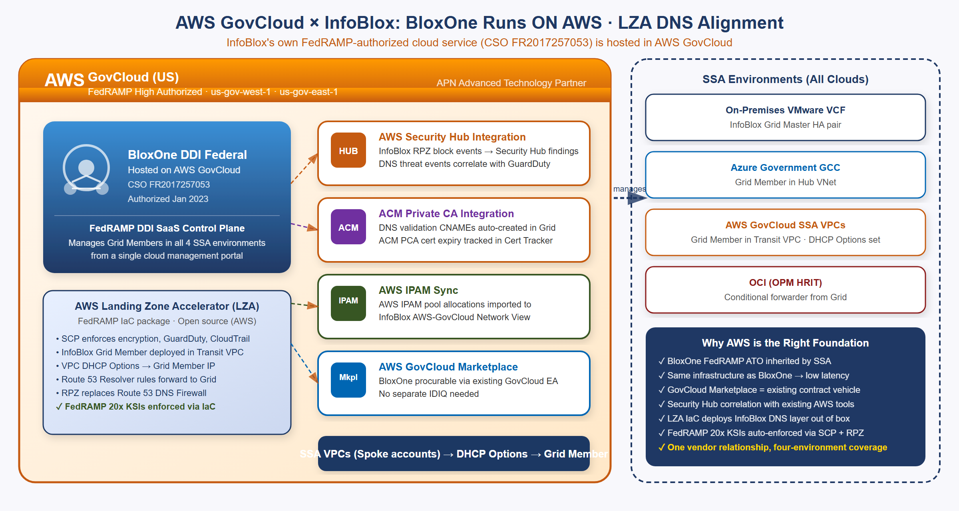
AWS GovCloud × InfoBlox — BloxOne DDI Federal Hosted on AWS, LZA DNS Alignment
The AWS relationship is the deepest of all three cloud vendors: InfoBlox’s own FedRAMP-authorized cloud service (BloxOne DDI Federal, CSO FR2017257053) is hosted on AWS GovCloud. This makes AWS the infrastructure foundation for InfoBlox’s SaaS control plane.
Key Point: When SSA uses BloxOne DDI Federal, the control plane is hosted on AWS GovCloud infrastructure with its own FedRAMP High authorization. SSA inherits both the InfoBlox DDI CSO (FR2017257053) and the AWS GovCloud infrastructure authorization — layered FedRAMP coverage.
AWS-specific InfoBlox capabilities:
- AWS Landing Zone Accelerator (LZA) Integration: LZA is the AWS-published IaC package for FedRAMP-compliant landing zones. InfoBlox integrates as the DNS customization layer, replacing the default Route 53 Resolver-only DNS with Grid Member + RPZ + DNSSEC. FedRAMP 20x KSIs are enforced via SCP + InfoBlox RPZ policy.
- AWS Security Hub: InfoBlox RPZ block events flow natively to Security Hub findings and correlate with GuardDuty detections.
- ACM Private CA Integration: InfoBlox auto-creates DNS validation CNAME records for ACM certificate issuance; ACM PCA certificate expiry is tracked in InfoBlox Certificate Tracker.
- AWS IPAM Sync: AWS IPAM pool allocations are imported into InfoBlox’s AWS-GovCloud Network View — cross-cloud CIDR conflict detection includes native AWS IPAM-managed ranges.
- AWS GovCloud Marketplace Procurement: BloxOne DDI Federal is procurable via the GovCloud Marketplace against existing EA agreements — no separate IDIQ or procurement action required.
Route 53 Private Zone DNSSEC Gap: AWS Route 53 private hosted zones cannot be DNSSEC-signed — this is a documented AWS platform limitation as of 2026. InfoBlox Grid Members sign all internal zones including private SDN segments, closing this gap. This is a key differentiator for FedRAMP SC-20/SC-21 evidence.

Oracle Cloud / OCI: OPM HRIT Future Integration
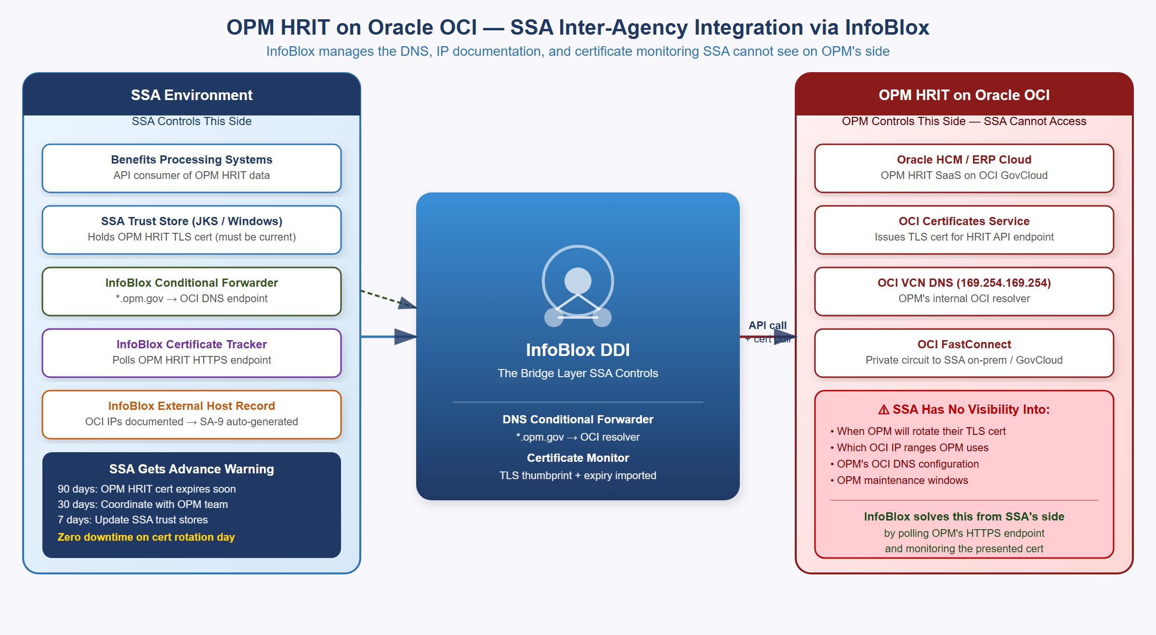
OPM HRIT on Oracle OCI — SSA Inter-Agency Integration via InfoBlox Certificate Monitor
OPM is migrating OPM HRIT (federal HR and benefits processing) to Oracle HCM Cloud on OCI. As OPM’s OPM HRIT moves to OCI-hosted SaaS, SSA’s integration path changes from a mainframe handoff to a cloud API call from SSA’s environment to OPM’s OCI-hosted service endpoints.
The challenge: OPM controls their OCI tenancy. SSA has no visibility into OPM’s certificate rotation schedule, IP range changes, or maintenance windows. When OPM rotates their OPM HRIT API TLS certificate without SSA’s trust stores being updated, the OPM HRIT API call fails — personnel action feeds stop, benefits enrollment breaks.
InfoBlox manages SSA’s side of the integration:
OPM HRIT Integration via InfoBlox {.striped .hover}
Integration Layer | InfoBlox Capability
DNS resolution | Conditional forwarder: *.opm.gov → OCI DNS endpoint; InfoBlox resolves from SSA network
IP documentation | OPM HRIT OCI IPs imported as external host records (read-only OCI Network View); SA-9 table auto-generated
Certificate monitoring | InfoBlox Certificate Tracker polls OPM HRIT HTTPS endpoints; captures TLS cert thumbprint + expiry
Expiry alerting | 90/30/7-day alerts give SSA advance notice of OPM cert rotation
Trust store prep | New OPM cert thumbprint pre-staged in InfoBlox before rotation day — zero-downtime update
The OPM HRIT Pattern Repeats: OPM HRIT on OCI is the first of many federal inter-agency SaaS integrations (OPM, DHS, IRS, VA are all moving shared services to cloud SaaS). InfoBlox gives SSA the monitoring layer it needs for every inter-agency dependency: conditional DNS forwarders, Certificate Tracker, and external host records — from SSA’s side, without requiring API access to the partner agency’s cloud tenancy.

Certificate Management and Cloud PKI Integration
Software Defined Networking eliminates IP address broadcasts but creates a new requirement: in an SDN environment where workloads are ephemeral and IPs change frequently, every service-to-service call must be mutually authenticated with certificates. Certificate subject names (CN and SAN fields) must match DNS names registered in the DNS system — which InfoBlox manages. InfoBlox is therefore the natural integration point for certificate lifecycle management. This is not a convenience pairing: certificate issuance is itself a naming-plane function — CAA records govern which CAs may issue for a zone, and ACME DNS-01 validation proves domain control through the DNS the Grid is authoritative for. The full cryptographic-identity architecture built on this substrate is Book 03.
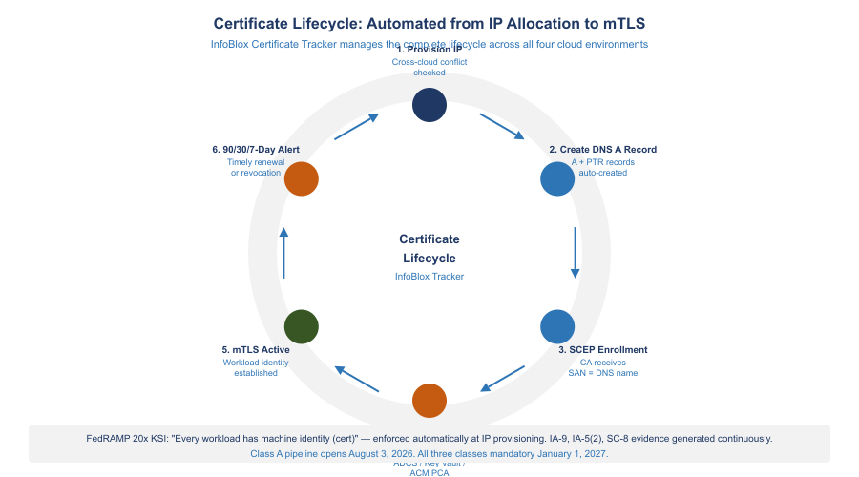
Certificate Lifecycle: Automated from IP Allocation to mTLS

The Certificate Lifecycle in a Multi-Cloud SDN Environment
The complete certificate lifecycle for a cloud workload follows this sequence:
- VM or container provisioned by VCF Automation, Terraform, or cloud-native IaC
- InfoBlox IPAM allocates an IP from the correct Network View (cross-cloud conflict-checked)
- InfoBlox Grid automatically creates a DNS A record: workload-name.environment.agency.gov → IP
- Workload bootstrap sends SCEP or EST enrollment to the agency CA using the DNS name as the certificate SAN
- CA (ADCS, Azure Key Vault with SCEP, AWS ACM Private CA) issues a certificate binding the SAN to the workload
- InfoBlox Certificate Tracker receives the certificate thumbprint, expiry, and issuing CA, binding it to the IP host record
- mTLS is active: the workload presents the certificate to authenticate to other services
- 90/30/7 days before expiry, InfoBlox Certificate Tracker generates alerts for timely renewal

Integration with Each Cloud Certificate Manager
Certificate Manager Integrations {.striped .hover}
Platform | Integration Method | InfoBlox Role
ADCS (On-Prem) | SCEP/EST connector; InfoBlox SCEP auto-enrollment | Triggers enrollment on IP host record creation; binds cert thumbprint to IP record
Azure Key Vault (GCC) | Azure Key Vault REST API polling | Imports cert metadata; correlates cert to Azure VM NIC IP; alerts on expiry
AWS ACM Private CA | ACM API; DNS validation CNAME auto-creation | Creates ACM validation CNAMEs in Grid; tracks ACM PCA cert expiry
Oracle OCI Certificates | HTTPS endpoint polling (no OCI API needed) | Imports OPM HRIT endpoint cert thumbprint; 90/30/7-day alerts to SSA team
Keyfactor / Sectigo CLM | Bidirectional API integration | InfoBlox as DNS name SSOT for cert SAN validation; CLM uses InfoBlox IP ranges for discovery scanning
Zero Trust Enabler: Certificate-to-IP binding in InfoBlox is the technical foundation of ‘never trust, always verify’ at the network layer. When every IP host record carries a certificate thumbprint and expiry date, the network infrastructure itself becomes identity-aware — a core requirement of CISA’s Zero Trust Maturity Model Networks pillar at Advanced/Optimal level.
Cross-Book Link — NAC Endpoints and DNS/Certificate Binding (Books 02 and 03): The DNS A-record + SCEP certificate compound provisioning described above applies to cloud workloads (VMs and containers). For NAC-enrolled endpoint devices — laptops, workstations, and managed endpoints that authenticate via 802.1X EAP-TLS — the same compound pattern applies but is triggered differently:
- Intune/SCEP enrollment (covered in Book 02) issues the machine certificate with CN={{DeviceName}} and SAN bound to the device’s Entra ID FQDN.
- DNS A/PTR record for the endpoint should be confirmed or created in InfoBlox at DHCP lease assignment — binding the device’s DNS hostname (from Entra ID) to the DHCP-assigned IP address in the IPAM record.
- Together, steps 1 and 2 produce a device where name, address, and key are bound at admission — the same compound guarantee that workload provisioning achieves, extended to the endpoint population.
This linkage — that every NAC-admitted device carries both a DNS hostname and a machine certificate, and that InfoBlox holds the authoritative binding record — is the shared foundation of Book 02 (NAC/802.1X) and Book 03 (Cryptographic Identity). The design decision for this binding must be validated with OIS.

Subdomain Strategy and Namespace Design
A unified DDI control plane governs DNS only as well as the namespace it manages. InfoBlox can enforce policy, automate lifecycle, and generate compliance evidence across every zone it is authoritative for — but the structure of those zones determines whether the platform scales cleanly or accumulates the same sprawl it was deployed to fix. Subdomain strategy is the architectural decision that makes the DDI investment operationally sustainable.
In modern hybrid multi-cloud environments, DNS is a control plane — not merely a name-to-IP directory. The namespace structure determines security policy scope (which RPZ rules apply to which services), certificate coverage (what wildcards are valid and at what depth), split-horizon resolution boundaries (which records are private vs. public), and the granularity of observability (whether a DNS query log entry identifies a cloud, environment, and service from the FQDN alone). Without deliberate namespace design, the outcome is DNS sprawl, certificate chaos, and opaque logs.

Why Legacy DNS Fails in Multi-Cloud
Legacy DNS was designed for a flat environment: one zone, manual A records, a single trust boundary. SSA now operates across four cloud environments with dynamic workloads, ephemeral IPs, and a security model where every service-to-service call is mutually authenticated by certificate. Three failure modes emerge without namespace governance:
Certificate chaos. Wildcard certificates (*.ssa.gov) match one label to the left of the wildcard per RFC 6125 — they cover api.ssa.gov but not prod.api.ssa.gov. Without consistent subdomain depth, every new workload either requires a dedicated SAN certificate or causes a multi-SAN certificate to be manually updated. Structured subdomains enable structured wildcards: *.api.ssa.gov covers all API workloads at one wildcard.
Uncontrolled split-brain. When internal and external DNS are not deliberately separated, the same FQDN resolves to different addresses by accident. Controlled split-horizon DNS is the same mechanism — intentional. Internal users get private resolution; external users get public resolution; InfoBlox view policy enforces both. Accidental split-brain is a misconfiguration; deliberate split-horizon is a security boundary.
Opaque observability. When all workloads resolve through undifferentiated names, a DNS query log cannot identify the cloud, environment, or service from the FQDN. prod.api.azure.ssa.gov is self-documenting. svc-443-node7.ssa.gov is not.

SSA Namespace Structure
The following hierarchy applies five patterns — functional, geographic, environment, cloud-provider, and hybrid split-horizon — to SSA’s four-environment topology. Each leaf is a separately delegated zone in InfoBlox with its own DNSSEC signing policy, RBAC delegation, and RPZ attachment.
ssa.gov (root — public, DNSSEC-signed, minimal records)
├── internal.ssa.gov (split-view — private resolution only, never public)
│ ├── vmw.internal.ssa.gov (VMware VCF on-premises workloads)
│ ├── azure.internal.ssa.gov (Azure Government private endpoints, Arc-enrolled servers)
│ ├── aws.internal.ssa.gov (AWS GovCloud VPC workloads)
│ └── oci.internal.ssa.gov (Oracle OCI / OPM HRIT resources)
├── api.ssa.gov (backend services — split-view or public)
│ ├── prod.api.ssa.gov
│ └── staging.api.ssa.gov
├── auth.ssa.gov (Entra ID, SAML, OIDC endpoints)
├── vc.ssa.gov (video conferencing — Pexip, Teams Connector)
├── mgmt.ssa.gov (Azure Arc, Intune enrollment, management plane)
└── mon.ssa.gov (monitoring — ThousandEyes, Azure Monitor)
SSA Subdomain Namespace Hierarchy — ssa.gov Zone Architecture
Depth guideline: Prefer three labels or fewer. prod.api.ssa.gov is preferable to us-east.prod.api.ssa.gov unless geography carries an independent operational meaning (separate certificate, separate RPZ policy, separate routing). Each additional label multiplies certificate scope complexity and diagnostic friction.

Wildcard Certificate Alignment
The namespace structure directly determines certificate coverage. Each functional subdomain enables one wildcard covering all workloads in that function:
Wildcard certificate scope by namespace level {.striped .hover}
Wildcard | Covers | Does Not Cover
*.ssa.gov | api.ssa.gov, vc.ssa.gov, auth.ssa.gov | prod.api.ssa.gov, us-east.vc.ssa.gov
*.api.ssa.gov | prod.api.ssa.gov, staging.api.ssa.gov | deeper labels
*.internal.ssa.gov | vmw.internal.ssa.gov, azure.internal.ssa.gov | deeper labels
*.vc.ssa.gov | all video conferencing endpoints | deeper labels
The certificate lifecycle described in [Section -@sec-certs] — SCEP enrollment triggered by InfoBlox IP host record creation — follows this wildcard boundary. When a new workload provisions in azure.internal.ssa.gov, InfoBlox creates the DNS record and triggers SCEP enrollment against the Azure GCC private CA, issuing a certificate with a SAN valid under *.azure.internal.ssa.gov. The namespace zone determines the CA path; no per-workload certificate configuration is required.

Split-Horizon DNS — InfoBlox View Configuration
Split-horizon DNS configures InfoBlox to return different answers to the same query depending on the requestor’s source network. Internal SSA users receive private IP addresses; external internet requestors receive public IPs or NXDOMAIN for private-only zones. The application FQDN is identical in both cases — the split is enforced at the InfoBlox view layer, transparent to clients.
InfoBlox DNS views for SSA’s four-environment topology:
InfoBlox DNS view configuration for SSA {.striped .hover}
View | Source Networks | Zones Served | Private IPs Exposed
internal-view | 10.0.0.0/8, VPN pool CIDRs | internal.ssa.gov, ssa.gov (private records) | Yes
cloud-internal-view | Azure VNet CIDRs, AWS VPC CIDRs, OCI VCN CIDRs | *.internal.ssa.gov, conditional forwarders to cloud-native DNS | Yes
external-view | All other sources (internet) | ssa.gov public records only, DNSSEC-signed | No
The internal.ssa.gov zone exists only in the internal-view. A request from an internet source hits the external-view, which has no internal.ssa.gov zone — the response is NXDOMAIN. Private IP space never appears in the external view.
Integration with cloud-native DNS: Azure Private DNS Zones (e.g., privatelink.database.windows.net for SQL managed instances) are reachable from on-premises via conditional forwarders in InfoBlox — queries for *.privatelink.database.windows.net are forwarded to the Azure Private DNS Resolver inbound endpoint in SSA’s Azure VNet. AWS Route 53 Resolver inbound endpoints serve the same function for GovCloud VPC private zones. Legacy Active Directory DNS servers forward queries for modern subdomains (api.ssa.gov, vc.ssa.gov) to InfoBlox via stub zones — AD DNS remains authoritative only for Kerberos and LDAP SRV records.
M365 GCC boundary enforcement via split-horizon: The external-view resolves M365 endpoints to public Microsoft IPs. The internal-view enforces the M365 GCC allow-list via RPZ — clients inside SSA’s network that resolve a Microsoft endpoint not on the current GCC allow-list receive an RPZ block response before any TCP connection is attempted. The split-horizon view is the enforcement boundary; the allow-list is the policy.
InfoBlox Split-Horizon DNS — Three-View Configuration for SSA

IaC and Automation Integration
The InfoBlox Terraform provider (infoblox/infoblox) manages zones, records, and views as infrastructure-as-code. All zone creation and delegation follows the same GitOps pipeline as SSA’s cloud infrastructure.
# Functional zone for video conferencing — delegated with RBAC to AV team
resource "infoblox_zone_auth" "vc_zone" {
fqdn = "vc.ssa.gov"
view = "external"
comment = "Pexip and Teams Connector endpoints"
}
# Blue/green Teams Connector — low TTL for fast cutover
resource "infoblox_cname_record" "teamsconn_active" {
alias = "teamsconn.vc.ssa.gov"
canonical = "blue.teamsconn.vc.ssa.gov" # swap to green.teamsconn.vc.ssa.gov for cutover
view = "internal-view"
ttl = 60
}
vDiscovery naming templates: InfoBlox vDiscovery continuously scans all four cloud environments and auto-populates DNS records and IPAM entries. The naming template determines which zone receives the auto-populated record:
vDiscovery naming templates by cloud platform {.striped .hover}
Platform | vDiscovery Template | Zone
VMware vSphere | {vm_name}.vmw.internal.ssa.gov | vmw.internal.ssa.gov
Azure Government | {resource_name}.azure.internal.ssa.gov | azure.internal.ssa.gov
AWS GovCloud | {instance_name}.aws.internal.ssa.gov | aws.internal.ssa.gov
Oracle OCI | {instance_name}.oci.internal.ssa.gov | oci.internal.ssa.gov
When a new VM provisions in any environment, InfoBlox creates the DNS record in the correct zone, allocates the IPAM entry in the correct Network View, and triggers SCEP enrollment in the correct CA — all from the zone the record belongs to. The namespace is the configuration.
Kubernetes external-dns: For Kubernetes workloads on any platform, the external-dns controller creates and removes InfoBlox DNS records as services come and go. A Service annotated with external-dns.alpha.kubernetes.io/hostname: payments.api.ssa.gov results in an A record in prod.api.ssa.gov pointing to the load balancer IP — created on Service creation, removed on Service deletion, with no manual DNS management required.

RPZ Policy Scoping by Subdomain
DNS Firewall RPZ policies in InfoBlox attach at the zone level. The subdomain structure determines the security policy granularity:
RPZ policy attachment by subdomain zone {.striped .hover}
Zone | RPZ Policy
ssa.gov external view | CISA threat intelligence feed + M365 GCC allow-list
vc.ssa.gov | SIP/H.323 federation allow-list; block unapproved conferencing endpoints
internal.ssa.gov | Internal-only flag — NXDOMAIN for any external resolution attempt
mgmt.ssa.gov | Strict: allow-list of management-plane destinations only; block all others
A query resolving through mgmt.ssa.gov that does not match the management-plane allow-list returns an RPZ NXDOMAIN before any TCP connection is attempted. The subdomain boundary is the security boundary — without it, RPZ policy must be applied at the individual record level, which is operationally unmanageable at scale.

Additional NIST Controls from Namespace Design
The subdomain strategy adds three controls to the NIST mapping in [Section -@sec-nist]:
Additional controls from subdomain namespace design {.striped .hover}
Control | Title | Contribution
SC-22 | Architecture and Provisioning for Name/Address Resolution | Zone hierarchy with delegated authority and view separation enforcing internal/external boundary
AC-4 | Information Flow Enforcement | Internal views prevent DNS resolution from cloud environments to unapproved external destinations; RPZ at zone level enforces M365 GCC allow-list
SA-9 | External System Services | Conditional forwarders to Azure Private DNS Resolver and AWS Route 53 Resolver are documented zone-level dependencies with per-forwarder audit trail

DNS-Based Traffic Steering as a DDI Function
Global server load balancing has always been a DNS function wearing an appliance badge. When a hardware GSLB appliance decides which data center or cloud region answers a user’s request, the mechanism it uses is a DNS response: the appliance acts as an authoritative name server that answers the same query differently depending on endpoint health, requestor topology, and policy weight. Strip away the chassis, and what remains is health-checked, policy-driven authoritative DNS — a control-plane function of the naming and addressing layer, not a data-plane function of any appliance tier.
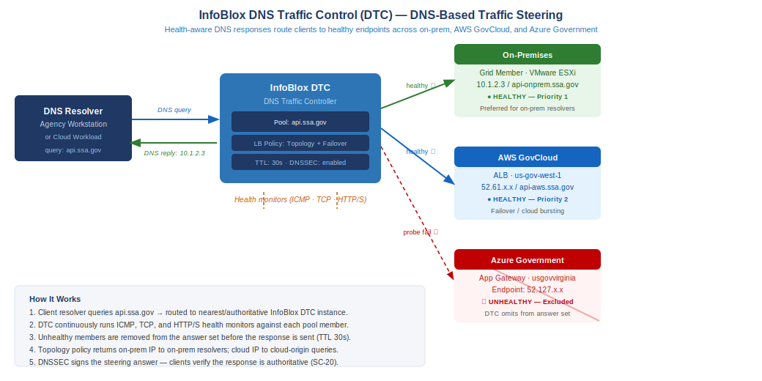
InfoBlox DTC — DNS-Based Traffic Steering Across On-Premises and Multi-Cloud Endpoints
Modern DDI platforms implement this function natively. InfoBlox DNS Traffic Control (DTC) attaches health monitors (ICMP, TCP, HTTP/S) to pools of service endpoints and computes each A/AAAA response at query time from pool member health, topology rules, and weighted ratios — a degraded endpoint simply stops appearing in answers, within one TTL, with no traffic ever passing through the Grid Member. The cloud providers expose the same function as DNS routing policy: Route 53 weighted, latency-based, geolocation, and failover routing policies; Azure Traffic Manager profiles; OCI Traffic Management steering policies. In every case the steering decision executes in the resolution path, and the “load balancer” is the answer itself.
This matters to the landing zone because the hardware application-delivery tier is dissolving, and its two halves land in two different places. The local half — reverse proxy, TLS offload, per-request distribution — dissolves into cloud-native delivery services provisioned in the landing zone (Azure Application Gateway and Front Door, AWS ALB/NLB, OCI Load Balancer), deployed per workload through the same IaC pipeline as everything else in this document. The global half — steering users between sites, regions, and clouds — dissolves into the DNS control plane this book builds. Neither half survives as an appliance tier to migrate; the forty-year history of how that tier accumulated, and why SD-WAN retires the WAN edge rather than replacing the load balancer, is told in Book 05.
Because global steering is DNS, every property this document establishes for the DDI plane applies to it automatically. Steering responses are served from zones the Grid signs, so DNSSEC covers the steering answer (SC-20). Steering configuration is managed as code through the same Terraform provider that manages zones and records (CM-2). Every steering decision is a logged DNS response in the unified syslog stream — a regional failover event is not an invisible appliance state change but an auditable sequence of answer changes with timestamps (AU-12, CA-7). And split-horizon views scope steering policy exactly as they scope every other record: internal requestors can be steered to private endpoints while external requestors are steered across public ones, from the same LBDN object.
The practical consequence for the buildout roadmap: when application teams ask where global traffic steering lives in the target architecture, the answer is not “procure a GSLB replacement.” The answer is that the capability is already present in the DDI layer deployed in Phases 1–4 — it is a policy configuration on the naming plane, inheriting the DNSSEC, IaC, and audit posture the landing zone already established.

NIST SP 800-53 Rev 5 Control Mapping
The following table maps InfoBlox DDI landing zone capabilities to specific NIST SP 800-53 Rev 5 controls. A single InfoBlox deployment provides evidence for 16 controls that would otherwise require separate evidence collection from four separate platforms.
NIST SP 800-53 Rev 5 Control Coverage {.striped .hover}
Control | What InfoBlox DDI Provides | Evidence Artifact | Satisfies
SC-20 | DNSSEC signing of all DNS zones including internal SDN segments | DNSSEC key log; DS record at .gov registrar | SC-20, SC-20(1)
SC-21 | Recursive DNSSEC validation on all Grid Members; RPZ with CISA Protective DNS feed | RPZ hit log → SIEM; validation failure alert | SC-21
SC-22 | Network Insight auto-generates DDI topology; Grid Master-to-Member map | Network Insight export; SSP Appendix J | SC-22
SC-7 | RPZ enforces domain-level egress blocking across all four SDN environments; DNS exfiltration detection | RPZ block rate dashboard; exfil alert config | SC-7, SC-7(7)
SC-8 | mTLS between workloads via certificate-to-IP binding; SCEP/EST enrollment before service traffic | Certificate Tracker report; mTLS config | SC-8, SC-8(1)
CM-8 | Every IP host record = CM-8 inventory item; SDN connector enriches with VM name, OS, owner, cloud region | IP host record export to ServiceNow CMDB | CM-8, CM-8(1)
CM-2 | IaC integration creates IP+DNS+cert records atomically and destroys them on decommission | Terraform state; IP lifecycle audit log | CM-2, CM-6
SA-9 | External DNS registered as governed external services; all forwarded queries logged; OPM HRIT documented | Forwarder config export; SSP SA-9 table | SA-9
IA-5(2) | Certificate Tracker links cert thumbprint+expiry+issuer to IP host record; ADCS/Key Vault/ACM/OCI cert metadata | Cert inventory report; expiry alert log | IA-5(2)
IA-9 | Every SDN workload receives a certificate via SCEP/EST automation at provisioning time | SCEP enrollment log; cert-to-IP binding report | IA-9
AU-2 | DNS query events, DHCP lease events, IP allocation events, and cert enrollment events defined and logged | SIEM event catalog; AU-2 event list | AU-2
AU-12 | Single syslog stream from all Grid Members across all four SDN environments; RFC 5424 format; 3-year retention | SIEM dashboards; retention policy | AU-12
IR-4 | RPZ block events auto-generate SIEM IR tickets; DNSSEC failure triggers SOC alerts; DNS exfil detection | IR playbook; RPZ alert→ticket pipeline | IR-4, IR-5
SI-3 | DNS-layer malware blocking via RPZ prevents resolution of C2 domains, ransomware, phishing | RPZ block count by threat category | SI-3, SI-3(1)
PL-8 | Unified DDI architecture in SSP; InfoBlox FedRAMP ATO cited as inherited control for DDI layer | SSP Section 13 architecture narrative | PL-8
Closure Necessity — SC-20 / SC-21 / SC-22 (authoritative DNS). SC-20 requires the system to provide origin authentication and integrity verification artifacts with authoritative name resolution responses; SC-21 requires requesting systems to perform validation on the responses they receive; SC-22 requires the resolution architecture itself to be fault-tolerant and role-separated. All three controls presuppose an authoritative naming plane, because there is nothing else that can close them: you cannot attest authoritative name resolution without an authoritative resolver. No scanner creates a source of truth — a scanner, a compliance dashboard, or a conformance tool can only measure drift from a source of truth that must already exist. The DNSSEC-signed, view-separated Grid described in this document is not one implementation option among several; it is the class of mechanism these controls name.

CISA Zero Trust Maturity Model v2.0 Alignment
CISA’s Zero Trust Maturity Model v2.0 (April 2023) defines five pillars and three cross-cutting capabilities across four maturity stages: Traditional → Initial → Advanced → Optimal.
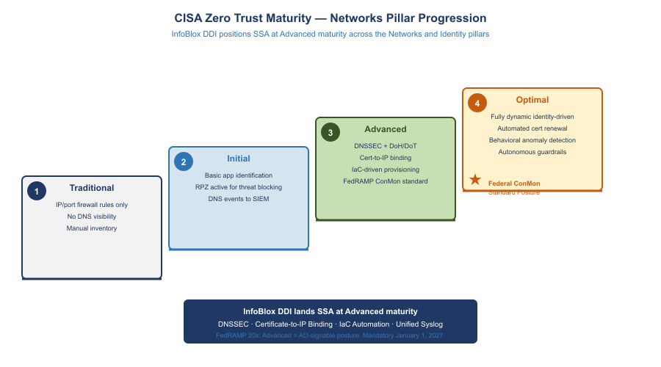
CISA Zero Trust Maturity — Networks Pillar Progression

Networks Pillar (Deepest Alignment)
CISA Zero Trust Networks Pillar Alignment {.striped .hover}
CISA ZT Network Requirement | InfoBlox DDI Implementation | ZT Maturity Level
Encrypt DNS traffic (DoH/DoT) | Grid Members support DoH/DoT for client queries; DNSSEC validates response integrity end-to-end | Advanced → Optimal
Implement Protective DNS | RPZ with CISA Protective DNS feed + TIDE commercial threat intel; blocks C2, phishing, DNS tunneling across all SDN environments | Initial → Advanced
DNS visibility for all workloads | Unified syslog from all Grid Members; every DNS query logged with client IP, query name, response, latency | Initial → Advanced
IPAM as segmentation enforcement | Network Views enforce CIDR segregation; IaC cannot allocate overlapping CIDRs; segment-level records map to NSX-T security groups and Azure NSGs | Advanced
SDN micro-segmentation integration | NSX-T security groups can reference InfoBlox IPAM tags (workload classification, owner) as dynamic membership criteria | Advanced → Optimal
Certificate-based network authentication | Certificate Tracker ensures every IP host record has a bound certificate; IP reputation replaced by certificate identity | Advanced → Optimal

Identity Pillar (Network-Layer Support)
InfoBlox supports the Identity pillar through certificate lifecycle management — the mechanism by which workload identity is established at the network layer:
- SCEP/EST automation issues certificates to every new workload at provisioning time, establishing machine identity before the first connection
- Certificate-to-IP binding enables network devices to verify workload identity from the DNS/IPAM layer without agent deployment
- Certificate expiry alerting prevents identity credential expiration — a common cause of authentication outages

Cross-Cutting: Visibility and Analytics
InfoBlox contributes three telemetry streams to CISA’s Visibility and Analytics capability:
- DNS query telemetry: every DNS resolution event from every SDN workload, with client IP, query type, response, latency, and RPZ action
- DHCP/IP event telemetry: every IP allocation, renewal, and release with device metadata
- Certificate telemetry: every expiry warning and enrollment event
All three streams flow to the SIEM in consistent syslog format — enabling correlation across DNS, IP, and certificate events that individually appear innocuous but together may indicate lateral movement or data exfiltration.

Cross-Cutting: Automation and Orchestration
InfoBlox’s IaC integrations directly enable the CISA Automation and Orchestration capability:
- Network resource provisioning (IP, DNS, cert) is automated in IaC pipelines — no manual steps that bypass policy
- VCF 9.1 native InfoBlox integration automates DDI for VMware workloads from day one
- RPZ updates are automated from threat intelligence feeds — human review required only for false positive exceptions

FedRAMP Boundary Enforcement
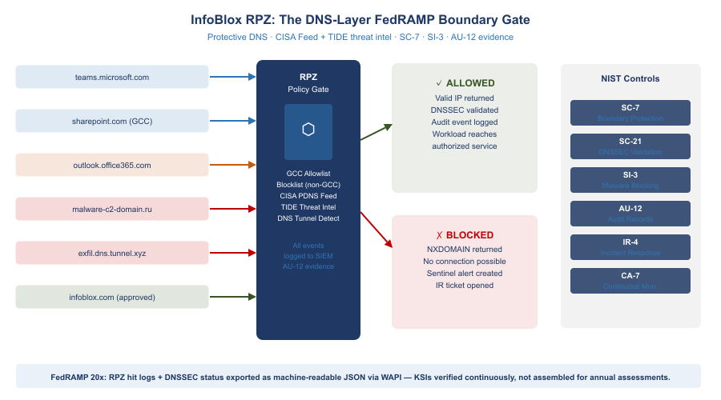
InfoBlox RPZ: The DNS-Layer FedRAMP Boundary Gate
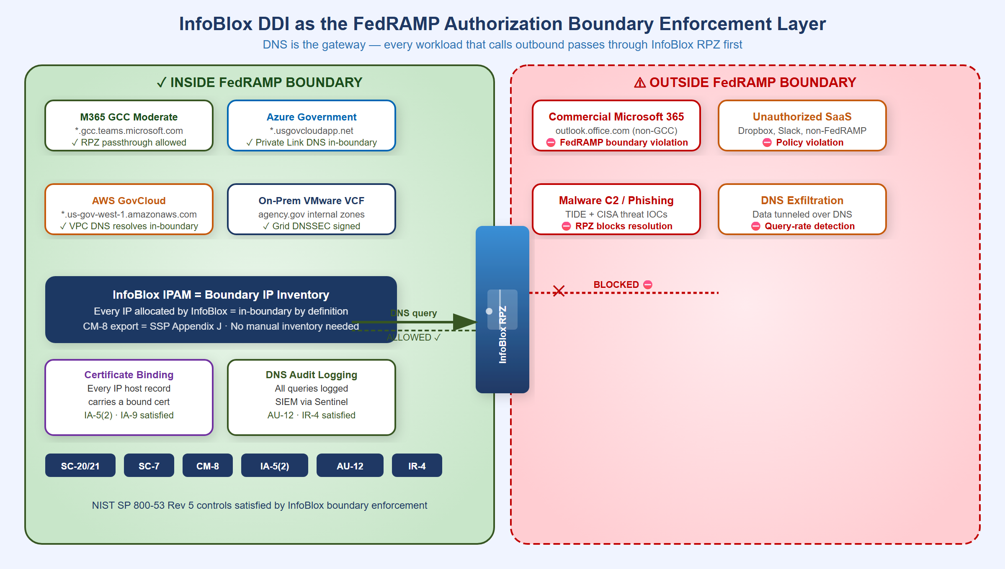
InfoBlox DDI as the FedRAMP Authorization Boundary Enforcement Layer
InfoBlox DDI enforces the FedRAMP authorization boundary at three layers simultaneously:
Layer 1 — IP Inventory = Boundary Definition. The FedRAMP authorization boundary is defined by IP address ranges. InfoBlox IPAM is the authoritative record of every IP inside the boundary. The CM-8 IP inventory export is the boundary IP list — no separate reconciliation required.
Closure Necessity — CM-8 (system component inventory). CM-8 requires an inventory that accurately reflects the system and includes all components within its boundary. You cannot inventory what you cannot enumerate — and the only layer that observes every component at the moment it joins the network is the addressing plane, because every component must take an address before it can do anything else. Discovery scanners enumerate what answered a probe during a scan window; an IPAM database enumerates what was allocated, which is the population the scanner’s results must be reconciled against. Without the enumeration substrate, a scan result is a sample with no denominator. DHCP fingerprinting extends the same substrate downward to device identity at the moment of lease — the port-level device inventory built on it is the subject of Book 02.
Layer 2 — DNS = Boundary Enforcement at Egress. Every DNS query from every workload passes through the InfoBlox Grid Member (because all VPC/VNet/NSX-T DHCP Options point to it). InfoBlox enforces:
- RPZ blocks commercial M365 endpoints (prevents FedRAMP data reaching non-GCC Microsoft infrastructure)
- RPZ blocks non-FedRAMP SaaS FQDNs (prevents workloads from reaching unauthorized cloud services)
- Conditional forwarders for external services generate the SA-9 documentation automatically
- DNSSEC validation required — DNS spoofing that could redirect traffic outside the boundary is rejected
- Query logging for all workloads — AU-12 evidence: every external communication visible in DNS logs
Layer 3 — Certificate Binding = Boundary Identity. Only IP host records within the InfoBlox IPAM database can receive certificates via SCEP/EST enrollment automation. Certificate possession = boundary membership — a powerful assertion for boundary documentation and IA-9 satisfaction.

FedRAMP Moderate and FedRAMP 20x Controls

FedRAMP Moderate: The Evidence Package
InfoBlox DDI produces a complete evidence package for FedRAMP Moderate annual assessments without manual evidence collection:
FedRAMP Moderate Evidence Package {.striped .hover}
Control Family | Evidence Source | Format | Collection
SC-20 / SC-21 | InfoBlox DNSSEC key rotation log; RPZ hit log | Grid audit log export | Automated
CM-8 | InfoBlox IP host record database | CSV / ServiceNow CMDB sync | API export on demand
IA-5(2) | InfoBlox Certificate Tracker | Certificate inventory report | API export on demand
AU-2 / AU-12 | SIEM fed by InfoBlox syslog stream | SIEM query results | Pre-built SIEM dashboards
IR-4 | SIEM IR playbook execution logs; RPZ alert ticket history | ServiceNow tickets | ITSM integration
SA-9 | InfoBlox External DNS Server config; SSP SA-9 table | InfoBlox config export | Grid config snapshot
SC-22 | InfoBlox Network Insight topology report | PDF / JSON topology export | Network Insight scheduler

FedRAMP 20x: Automated KSI Enforcement
FedRAMP published its Consolidated Rules for 2026 on June 25, 2026, establishing a single stable ruleset that supersedes the 20x pilot framework. Three classification tiers replace the single 20x path: Class A (simplest CSPs, opens August 3, 2026), Class B and Class C (open August 31, 2026). The Consolidated Rules become mandatory for all certified systems on January 1, 2027. New Rev5 certifications will no longer be accepted after June 11, 2027. Machine-readable rules are published in JSON format via GitHub, enabling AI agent integration and automated compliance verification.
For SSA’s multi-environment landing zone, InfoBlox DDI is well-positioned for the Class B or Class C pathway given its multi-cloud scope. The WAPI REST interface delivers structured JSON evidence for every KSI — no manual assembly required.
FedRAMP 20x replaces periodic evidence collection with continuously-verified Key Security Indicators enforced by infrastructure-as-code guardrails:
FedRAMP 20x KSI Automation {.striped .hover}
FedRAMP 20x KSI | InfoBlox Enforcement | Automated?
All DNS traffic encrypted or integrity-protected | DNSSEC on all zones; DoH/DoT endpoint on Grid Members | Yes — Grid policy
Protective DNS for all workloads | Grid Member = resolver for all VPC/VNet DHCP options; RPZ active | Yes — DHCP Options + RPZ
IP address inventory current and complete | API connectors sync in near-real-time; CM-8 report on demand | Yes — API connectors
No CIDR overlap between environments | Terraform InfoBlox provider blocks overlapping allocation at request time | Yes — Terraform
Certificate expiry monitored and auto-renewed | Certificate Tracker 90/30/7-day alerts; SCEP/EST auto-renewal workflow | Yes — Certificate Tracker
Every workload has machine identity (cert) | SCEP/EST enrollment triggered at IP host record creation | Yes — Auto-enrollment
DNS change events auditable | All DNS/DHCP/IP changes logged; syslog to SIEM in real time | Yes — Syslog + SIEM
FedRAMP 20x Positioning: InfoBlox DDI positions SSA ahead of the FedRAMP 20x transition. The machine-readable IP inventory (WAPI), automated KSI enforcement via IaC, and real-time SIEM integration align directly with FedRAMP 20x’s shift from periodic assessment to continuous automated verification.

Inter-Agency SaaS Integration: The OPM HRIT Template
OPM HRIT on OCI is the first of many federal inter-agency SaaS integrations. OPM, SSA, DHS, IRS, and VA are all moving shared services to cloud-hosted SaaS platforms. The pattern repeats every time:
- Agency A moves a shared service to cloud SaaS (OPM HRIT → OCI)
- Agency B (SSA) becomes an API consumer of that SaaS
- Agency B has no visibility into Agency A’s certificate rotation, endpoint changes, or IP range changes
- InfoBlox gives Agency B the monitoring layer it needs — from SSA’s side, without requiring access to the partner agency’s cloud
InfoBlox’s inter-agency integration toolkit:
- Conditional DNS forwarders — always know where the service resolves, even when the partner agency changes DNS
- Certificate Tracker endpoint polling — always know when the partner’s TLS cert will expire
- External host records — always document the partner’s IP ranges for SA-9 without API access to their cloud
- RPZ passthrough entries — ensure InfoBlox RPZ does not block the inter-agency API calls
- Sentinel alerts — detect if the inter-agency connection’s certificate has changed unexpectedly (potential MITM)

System Component Inventory — IPAM, CMDB, and the CM-8 Gap

IPAM Is Not an Asset Manager
InfoBlox IPAM is the network-layer addressing authority: every IP allocation, every DNS hostname, every DHCP lease, every machine certificate binding — from this plane’s point of view. It sees every device that has an IP address. It does not see:
- What software is installed on a device
- Whether a device’s OS is patched
- The organizational owner or data classification of a workload
- The FedRAMP boundary membership of an asset
- Relationships between assets (which application runs on which server, which server supports which system)
- Non-IP assets (smart cards, HSMs, air-gapped devices, physical media)
NIST SP 800-53 CM-8 (System Component Inventory) requires an inventory that includes hardware, software, firmware, and system interconnections — not just IP address records. InfoBlox satisfies the addressing dimension of CM-8; it does not satisfy the full control without a complementary CMDB.
SSA currently operates four asset management surfaces with no unified coordinator:
Surface | Scope | What It Misses
Microsoft Intune | Windows, macOS, iOS, Android managed endpoints | AWS EC2, OCI workloads, non-enrolled VMware VMs, network devices, IoT
Azure Arc (servers) | Windows Server + Linux on any cloud/on-prem — Arc-enrolled only | Workloads not explicitly Arc-onboarded; OCI-native resources; non-server assets
AWS Systems Manager (SSM) | AWS EC2 instances (agent-installed) | Azure, OCI, on-prem VMs; endpoint devices; network gear
VMware vCenter | On-premises VMware VMs and ESXi hosts | Cloud-native workloads; endpoints; network devices
InfoBlox IPAM bridges these surfaces at the IP layer — every asset managed by any of the four platforms above will have a DHCP/DNS record in InfoBlox. But correlating IP records to organizational ownership, FedRAMP boundary membership, patch state, and software inventory requires a platform above the addressing layer.

Open Decision — Asset Manager / CMDB Platform
SSA has not yet selected a unified Asset Manager / CMDB for cross-platform inventory coordination. This decision must be made by the CIO Office with OIS input — it is architecturally significant (determines the CM-8 evidence strategy) and has procurement implications. The requirements below define what the selected platform must satisfy. Specific product selection is pending agency review.

Requirements for the Asset Manager / CMDB
The following requirements must be satisfied by whichever platform SSA selects. Requirements are grouped by compliance driver. All requirements must be satisfied regardless of product selection.
Asset Manager / CMDB Requirements {.striped .hover}
ID | Requirement | Control | Priority
R-01 | Cross-platform automated discovery — must ingest asset records from Intune, Azure Arc, AWS Systems Manager, OCI Management Agent, VMware vCenter, InfoBlox IPAM, and network device management platforms without manual data entry | CM-8 | Must
R-02 | IP/IPAM correlation — every asset record must link to an InfoBlox IPAM record; the IP address, DNS FQDN, and DHCP lease state from InfoBlox are the authoritative network-layer identity for each asset | CM-8, SC-22 | Must
R-03 | Machine certificate binding — asset records must carry the machine certificate thumbprint and expiry for managed devices, populated from Intune SCEP enrollment (endpoint devices) and from InfoBlox Certificate Tracker (workloads) | IA-5, SC-12, SC-17 | Must
R-04 | FedRAMP boundary classification — each asset record must carry environment tag (AWS GovCloud, Azure Government, OCI, on-prem VMware) and FedRAMP system boundary membership; assets in-boundary vs. out-of-boundary must be queryable | CM-8, CA-3 | Must
R-05 | Component owner assignment — each asset must be assignable to a CIO Component owner; Component owners have read/write access scoped to their own assets and read-only access to nothing beyond their scope | CM-8, AC-3, AC-6 | Must
R-06 | Audit trail for asset record changes — every discovery-driven or manual change to an asset record must produce a log entry with timestamp, change source, before/after state, and actor identity; logs must feed the SIEM | AU-3, AU-12, CM-8(1) | Must
R-07 | Network device coverage — must discover and maintain records for switches, routers, firewalls, load balancers, and wireless access points via SNMP, NetFlow, REST, or CDP/LLDP | CM-8 | Must
R-08 | Unmanaged / IoT / OT device visibility — devices identified by MAC address and DHCP fingerprint in InfoBlox that have no MDM enrollment must appear in the inventory as “unmanaged — device class: [fingerprint]”; these are CM-8 scope items even if they cannot be fully managed | CM-8, IA-3 | Must
R-09 | Software inventory per managed asset — installed software, version, and patch state linked to the asset record for all Intune-managed and Arc-enrolled assets | CM-8(1) | Should
R-10 | Deduplication across sources — when Intune, Arc, AWS SSM, and InfoBlox all report the same physical or virtual asset, the platform must produce a single normalized canonical record, not four separate entries | CM-8 | Must
R-11 | FedRAMP Moderate or High authorization — the platform must carry its own FedRAMP ATO at Moderate or High impact, or be deployed within SSA’s own FedRAMP boundary with appropriate documentation | FedRAMP | Must
R-12 | SIEM integration — must export asset inventory and change events to the SIEM (Book 13) for enrichment of security alerts with asset context | SI-4, CA-7 | Must
R-13 | ConMon evidence generation — must produce CM-8-compliant inventory exports (OSCAL format preferred) for the ConMon pipeline (Book 19) | CA-7 | Must
R-14 | API-first — all discovery, query, and reporting functions must be available via documented REST API for integration with the IaC pipeline and ConMon toolchain | CM-8 | Should
R-15 | Lifecycle tracking — asset records must carry lifecycle state (provisioning / active / decommissioning / retired) and must support automated decommission notification from InfoBlox (DHCP lease release triggers review) | CM-8(1) | Should

FedRAMP-Authorized Product Candidates
The following platforms have federal government deployments and FedRAMP authorization status relevant to this requirement. SSA must verify current FedRAMP Marketplace listings at time of procurement — authorization status changes and this list reflects a point-in-time assessment. No selection is made here; this is a landscape to inform the CIO Office’s evaluation.
FedRAMP-Authorized Asset Manager Candidates (verify FedRAMP Marketplace at time of procurement — status changes) {.striped .hover}
Platform | FedRAMP Status | Primary Strength | Key Gap for SSA | Requirements Met
ServiceNow Now Platform (ITOM + CMDB) | FedRAMP Moderate (Government Community Cloud, JAB P-ATO) | Broadest CMDB capability; native Discovery across cloud APIs, VMware, network, and MDM; widely deployed across federal civilian agencies; full lifecycle, ownership, and relationship tracking | High cost; complexity of implementation; Discovery requires agent or network-based scanning agents in each environment | R-01 through R-15 (all, with proper configuration)
Axonius Cybersecurity Asset Management | FedRAMP authorization — verify current status on FedRAMP Marketplace | Purpose-built for exactly this problem: correlates 800+ adapters (Intune, Arc, AWS SSM, OCI, VMware, InfoBlox, Qualys, Tenable) into a single deduplicated asset record; no agents required; fastest time-to-value for cross-platform correlation | Less mature CMDB lifecycle and change management than ServiceNow; ITSM integration requires connector work | R-01, R-02, R-03, R-05, R-06, R-08, R-10, R-11, R-12, R-14
Qualys Global Asset Inventory (GAI) / VMDR | FedRAMP Moderate (JAB P-ATO) | Strong cloud connector coverage (AWS, Azure, GCP); vulnerability context tied to asset record; agentless cloud scanning | Weaker normalization across MDM (Intune) and IPAM sources; primarily vulnerability-centric rather than CMDB-centric; limited certificate tracking | R-01 (partial), R-04, R-06, R-08, R-09, R-11
Tenable.sc (Security Center) | FedRAMP Moderate (JAB P-ATO) | Deep vulnerability and asset discovery; strong network device and IoT/OT coverage via passive network analysis (Nessus Network Monitor); widely deployed in federal agencies | Not a CMDB — does not support organizational ownership hierarchy, lifecycle tracking, or ITSM-style asset management; certificate tracking limited | R-01 (partial), R-06, R-07, R-08, R-09
Microsoft Defender for Cloud (GCC High) | FedRAMP High (as part of Microsoft GCC High) | Native integration with Azure Arc, Intune, Defender for Endpoint; cloud security posture management for Azure, AWS, GCP; no additional procurement for Microsoft-licensed agencies | Limited coverage of OCI, VMware non-Arc, network devices; not a general-purpose CMDB; strong for Microsoft estate, weak outside it | R-01 (partial — Microsoft scope), R-04, R-06, R-11
AWS Config + Systems Manager Inventory | FedRAMP High (AWS GovCloud) | Native AWS asset inventory; configuration history; Config Rules for compliance; no additional cost beyond AWS usage | AWS-only — no coverage for Azure, OCI, on-prem, or endpoint devices; cannot serve as the unified cross-environment coordinator | R-01 (AWS scope only), R-04, R-06, R-14
Ivanti Neurons for ITSM + Asset Management | FedRAMP Moderate (verify current status on FedRAMP Marketplace) | Comprehensive ITSM + CMDB + discovery; strong on endpoint asset management and patch management; federal deployments | Less cloud-native than ServiceNow for multi-cloud asset correlation; verify current FedRAMP scope and boundary | R-01 (partial), R-05, R-06, R-09, R-10, R-15

Recommended Evaluation Approach
SSA should evaluate candidates against requirements R-01 through R-15 in a structured proof-of-concept across three specific scenarios:
- Correlation test — take a single managed Windows laptop; confirm that the candidate platform produces one deduplicated asset record that includes the Intune MDM record, the InfoBlox DHCP record, the machine certificate from Intune SCEP, and the DNS FQDN. This is R-01, R-02, R-03, and R-10 simultaneously.
- Unmanaged device test — connect an IoT device (or a device not enrolled in Intune) to a NAC-controlled port; confirm that the device appears in the inventory within one DHCP lease cycle as an unmanaged asset with InfoBlox DHCP fingerprint data. This is R-08.
- Component owner scoping test — create two CIO Component owners in the candidate platform; confirm that each owner sees only their assigned assets and cannot access the other’s records. This is R-05.
Until a platform is selected and deployed, InfoBlox IPAM serves as the best-available addressing proxy for CM-8 — every in-scope IP address is documented, every DNS hostname is authoritative, and DHCP fingerprinting provides unmanaged device classification. This is not a full CM-8 closure; it is the network-layer foundation on which the CMDB will be built.

Architecture Summary
Full Landing Zone Architecture Summary {.striped .hover}
Layer | On-Premises VMware | Azure Government | AWS GovCloud | Oracle OCI (OPM) | InfoBlox Role
IP Assignment | NSX-T DHCP Profiles (VCF 9.1) | Azure fabric / ARM API | VPC DHCP Options / Nitro | OCI VNIC / 169.254.169.254 | IPAM SSOT via connectors
DNS Resolver | Grid Member (replaces AD DNS) | Azure DNS Private Resolver → Grid | VPC DHCP Options → Grid | OCI resolver → Grid forwarder | Unified recursive + DNSSEC
DNS Authority | Grid Master (agency.gov) | Grid Member + Azure Private DNS | Grid Member + Route 53 private | Grid forwarder + OCI DNS | Grid Master as SSOT
DHCP | InfoBlox Grid DHCP (HA pair) | Azure fabric (no Grid DHCP) | AWS VPC DHCP | OCI DHCP | On-prem native; cloud via API
IPAM | On-Premises Network View | Azure-GCC Network View | AWS-GovCloud Network View | OCI-OPM Network View (RO) | Single DB, 4 Network Views
Certificates | ADCS via SCEP/EST | Azure Key Vault; ARM API polling | ACM Private CA; validation CNAMEs | OCI Certs (OPM); cert polling | Certificate Tracker
Threat / RPZ | RPZ on Grid Members; TIDE + CISA | RPZ on Azure Grid Member | RPZ on AWS Grid Member | Grid forwarder RPZ | Single policy, all environments
Audit / SIEM | Syslog from Grid Members | Syslog from Azure Grid Member | Syslog from AWS Grid Member | Syslog from Grid forwarder | One syslog stream
FedRAMP Controls | SC-20/21, CM-8, AU-12, IR-4 | SC-20/21, SA-9, IA-5(2), CM-8 | SC-20/21, SA-9, IA-5(2), CM-8 | SA-9, IA-5(2) | Single evidence source

Recommended Buildout Roadmap
Each phase produces immediately usable compliance evidence and security value — there is no ‘big bang’ dependency before the first phase delivers results.
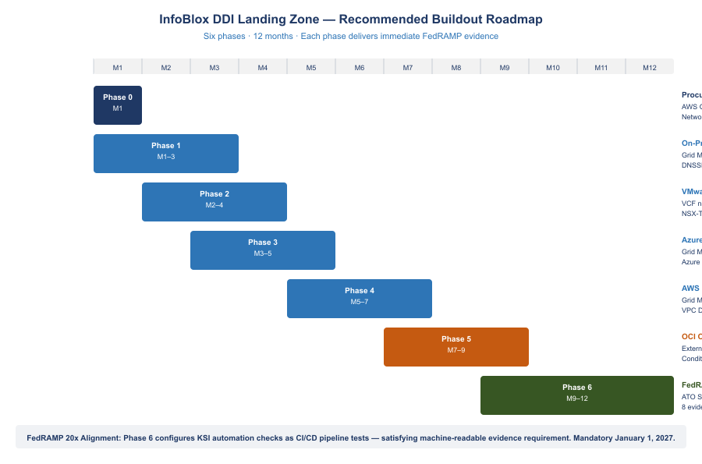
InfoBlox DDI Landing Zone — Six-Phase Buildout Roadmap

Phase 0 — Procurement and Architecture (Month 1)
- Procure InfoBlox BloxOne DDI Federal via AWS GovCloud Marketplace against existing EA (no new IDIQ)
- Reference FedRAMP Marketplace CSO FR2017257053 in procurement documentation
- Design Network View CIDR allocation plan: audit all existing IP ranges across on-prem, Azure VNet, AWS VPC, OCI VCN for overlaps
- Engage InfoBlox Professional Services for VCF 9.1 DDI integration workshop

Phase 1 — On-Premises Foundation (Months 1–3)
- Deploy Grid Master HA pair; import all AD DNS zones; enable DNSSEC for agency.gov
- Submit DS record to .gov TLD registrar (closes SC-20 gap)
- Migrate Windows Server DHCP scopes to InfoBlox Grid DHCP; enable DHCP fingerprinting (the device-identity feed that Book 02 builds the NAC device inventory on)
- Configure syslog forwarding from all Grid Members to SIEM (Splunk/Sentinel); verify AU-12 event receipt
- Deploy SCEP connector to ADCS; test automated cert enrollment from new IP host record
- Generate first CM-8 IP inventory export; reconcile against existing CMDB

Phase 2 — VMware VCF 9.1 Integration (Months 2–4)
- Update VCF to 9.1; configure VCF-A to use InfoBlox WAPI as external IPAM backend
- Update NSX-T DHCP Server Profiles to route DNS to InfoBlox Grid Member IP
- Verify NSX-T VM IP assignments appear in InfoBlox On-Premises Network View within 60 seconds

Phase 3 — Azure Government Integration (Months 3–5)
- Deploy InfoBlox Grid Member as Azure VM in Hub VNet; configure Azure DNS Private Resolver to forward to Grid Member
- Register all Azure VNet/subnet CIDRs in InfoBlox Azure-GCC Network View; enable Azure connector
- Configure Azure Key Vault Certificate Manager polling in InfoBlox Certificate Tracker
- Configure M365 GCC endpoint API polling; test RPZ passthrough and commercial M365 RPZ block

Phase 4 — AWS GovCloud Integration (Months 5–7)
- Deploy InfoBlox Grid Member as EC2 instance in Transit VPC
- Update VPC DHCP Options Sets to use Grid Member IP as domain-name-server
- Enable InfoBlox AWS connector; register all VPC CIDR allocations in AWS-GovCloud Network View
- Configure ACM DNS validation CNAME automation; test certificate issuance for an internal ALB
- Integrate InfoBlox RPZ events with AWS Security Hub findings

Phase 5 — OCI OPM HRIT Integration (Months 7–9)
- Import all known OPM HRIT service endpoint IPs and FQDNs as external host records
- Configure InfoBlox conditional forwarder for OPM HRIT FQDNs through FastConnect path
- Connect InfoBlox Certificate Tracker to OPM HRIT HTTPS endpoints; verify 90-day cert expiry alert fires
- Document OCI integration in SSP SA-9 external services table with OPM as system owner

Phase 6 — FedRAMP Continuous Monitoring (Months 9–12)
- Complete InfoBlox FedRAMP ATO documentation in SSP; reference CSO FR2017257053 for DDI layer control inheritance
- Configure all eight FedRAMP control evidence exports as scheduled reports
- Implement IaC Terraform pipeline: IP allocation → DNS record → SCEP cert enrollment as single atomic pipeline
- Configure FedRAMP 20x KSI automation checks (DNSSEC status, RPZ coverage, cert expiry, CIDR conflict) as CI/CD pipeline tests

References
References {.striped .hover}
Source | URL
InfoBlox FedRAMP Marketplace (CSO FR2017257053) | fedramp.gov/marketplace/products/FR2017257053
VMware VCF 9.1 InfoBlox DDI Integration (May 2026) | blogs.vmware.com/cloud-foundation
Register InfoBlox NIOS DDI with NSX — Broadcom TechDocs | techdocs.broadcom.com/…/integrate-nsx-with-infoblox
Microsoft 365 IP and URL Web Service | docs.microsoft.com/en-us/microsoft-365/enterprise/microsoft-365-ip-web-service
AWS VPC IP Address Manager (IPAM) | docs.aws.amazon.com/vpc/latest/ipam
Azure Virtual Network Manager IPAM (preview) | learn.microsoft.com/en-us/azure/virtual-network-manager/concept-ip-address-management
CISA Zero Trust Maturity Model v2.0 (April 2023) | cisa.gov/sites/default/files/2023-04/zero_trust_maturity_model_v2_508.pdf
FedRAMP 20x KSI Enforcement — AWS Public Sector | aws.amazon.com/blogs/publicsector/preventive-controls-for-fedramp-20x
InfoBlox NIOS 9.0 Certificate Management | docs.infoblox.com/space/nios90/280266962
AWS Landing Zone Accelerator on AWS (LZA) | github.com/awslabs/landing-zone-accelerator-on-aws
InfoBlox IPAM and DHCP Solutions | infoblox.com/solutions/ipam-dhcp
Configure DHCP for Azure VMware Solution (NSX-T) | learn.microsoft.com/en-us/azure/azure-vmware/configure-dhcp-azure-vmware-solution

